Writing Assignment
Compare and contrast the poet’s viewpoints about Mother Earth in “Mother Earth” by Denise Mckay and “Mother Earth Exists” by Carlene George. In your response, you must discuss both passages.
Guidelines For Your Response
• Show your understanding of both passages.
• Write approximately one to two pages.

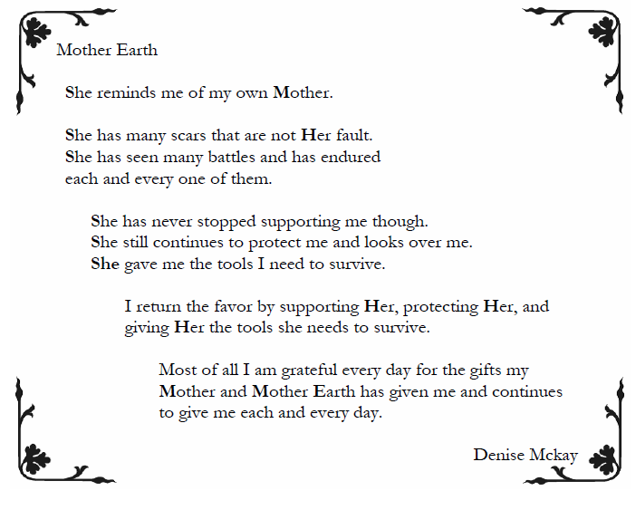

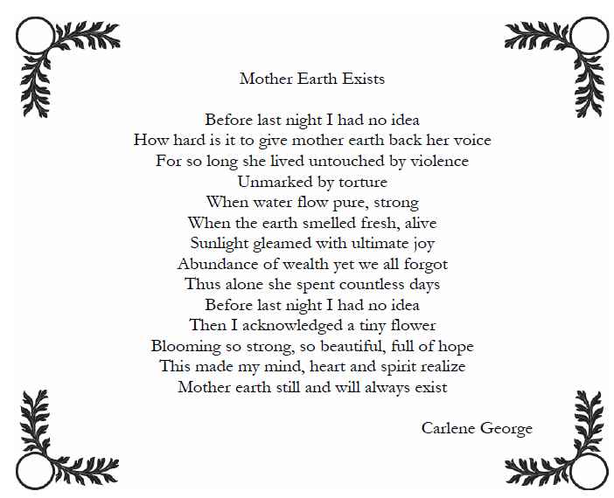
----------------------------------------------------------------------------------------------------------------------------------------------------------------

Compare and contrast the poet’s viewpoints about Mother Earth in “Mother Earth” by Denise Mckay and “Mother Earth Exists” by Carlene George. In your response, you must discuss both passages.
When putting down differences- put examples from the poems beside them to use when you are writing your answer to the question.
Differences- Mother Earth | Similarities- both poems | Differences-Mother Earth Exists

