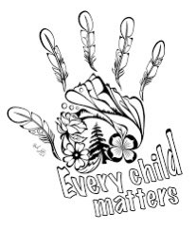

**THE WITNESS BLANKET**

**TRUTH AND RECONCILIATION IN ACTION**

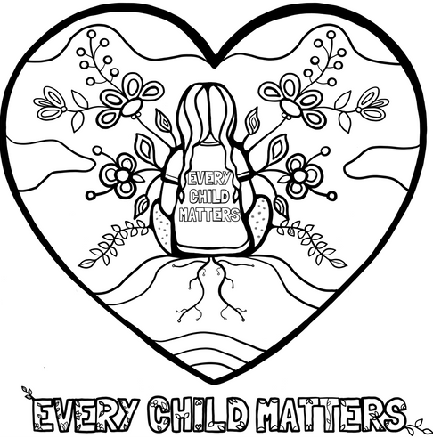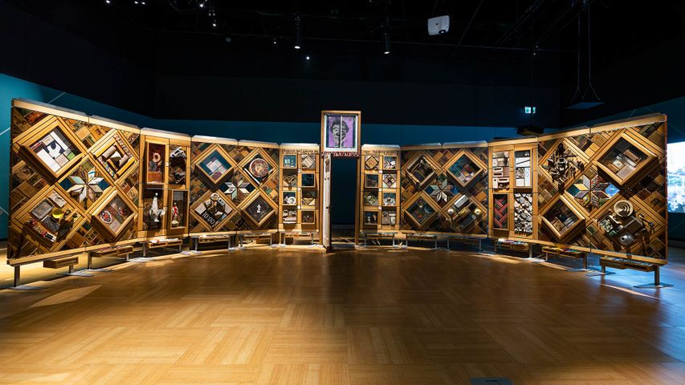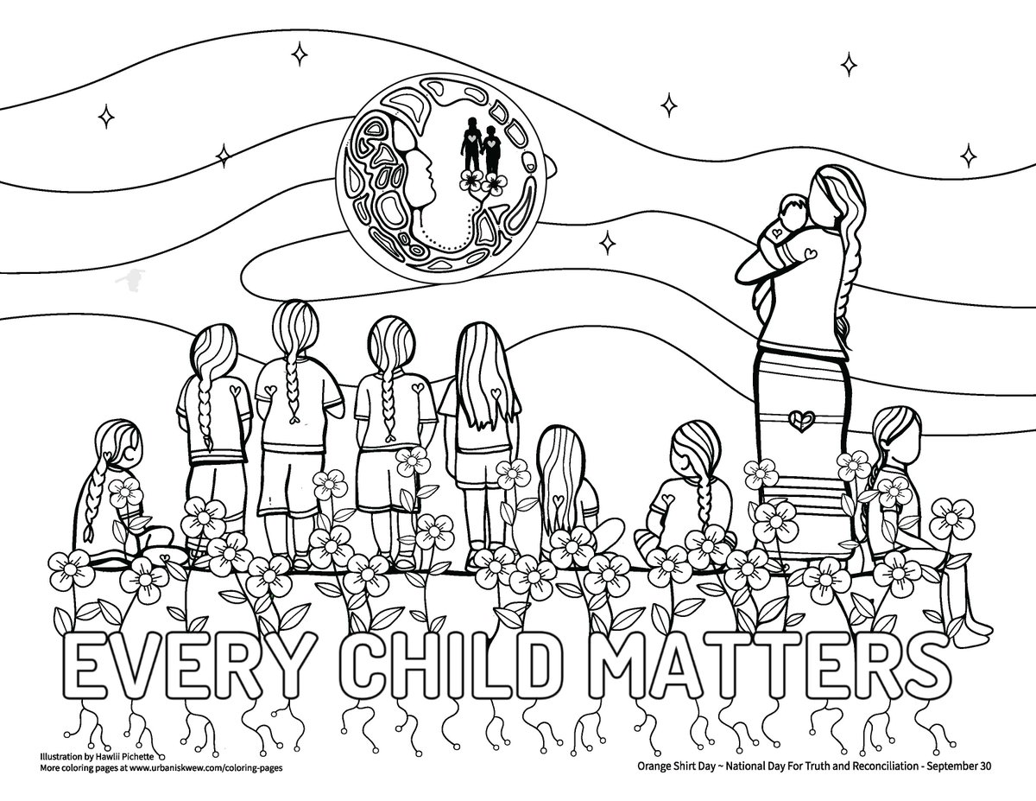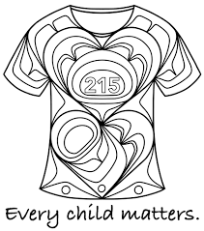

ARTWORK BY

HAWLII PICHETTE

ARTWORK BY

HAWLII PICHETTE

ARTWORK BY MICHELLE STONEY

ARTWORK BY MICHELLE STONEY

ARTWORK BY

YASAKW YAKGUJANAAS

ARTWORK BY

YASAKW YAKGUJANAAS

**W**

**I**

**T**

**N**

**E**

**S**

**S**

**B**

**L**

**A**

**N**

**K**

**E**

**T**

ARTWORK BY HAWLII PICHETTE