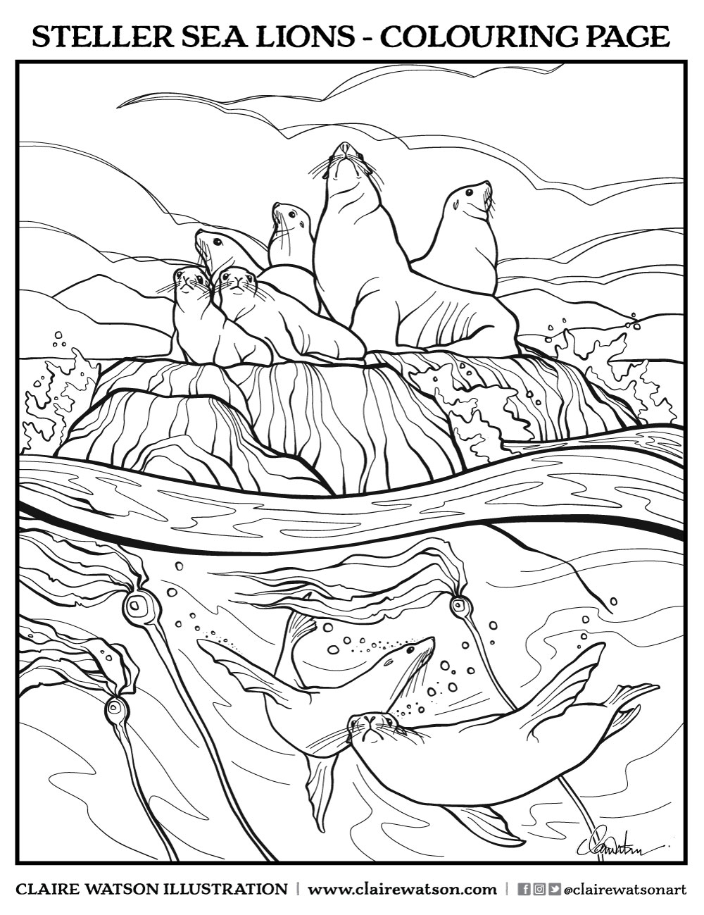
September Steller Sea Lions - Colouring Page — CLAIRE VICTORIA // Art, Illustration and Design
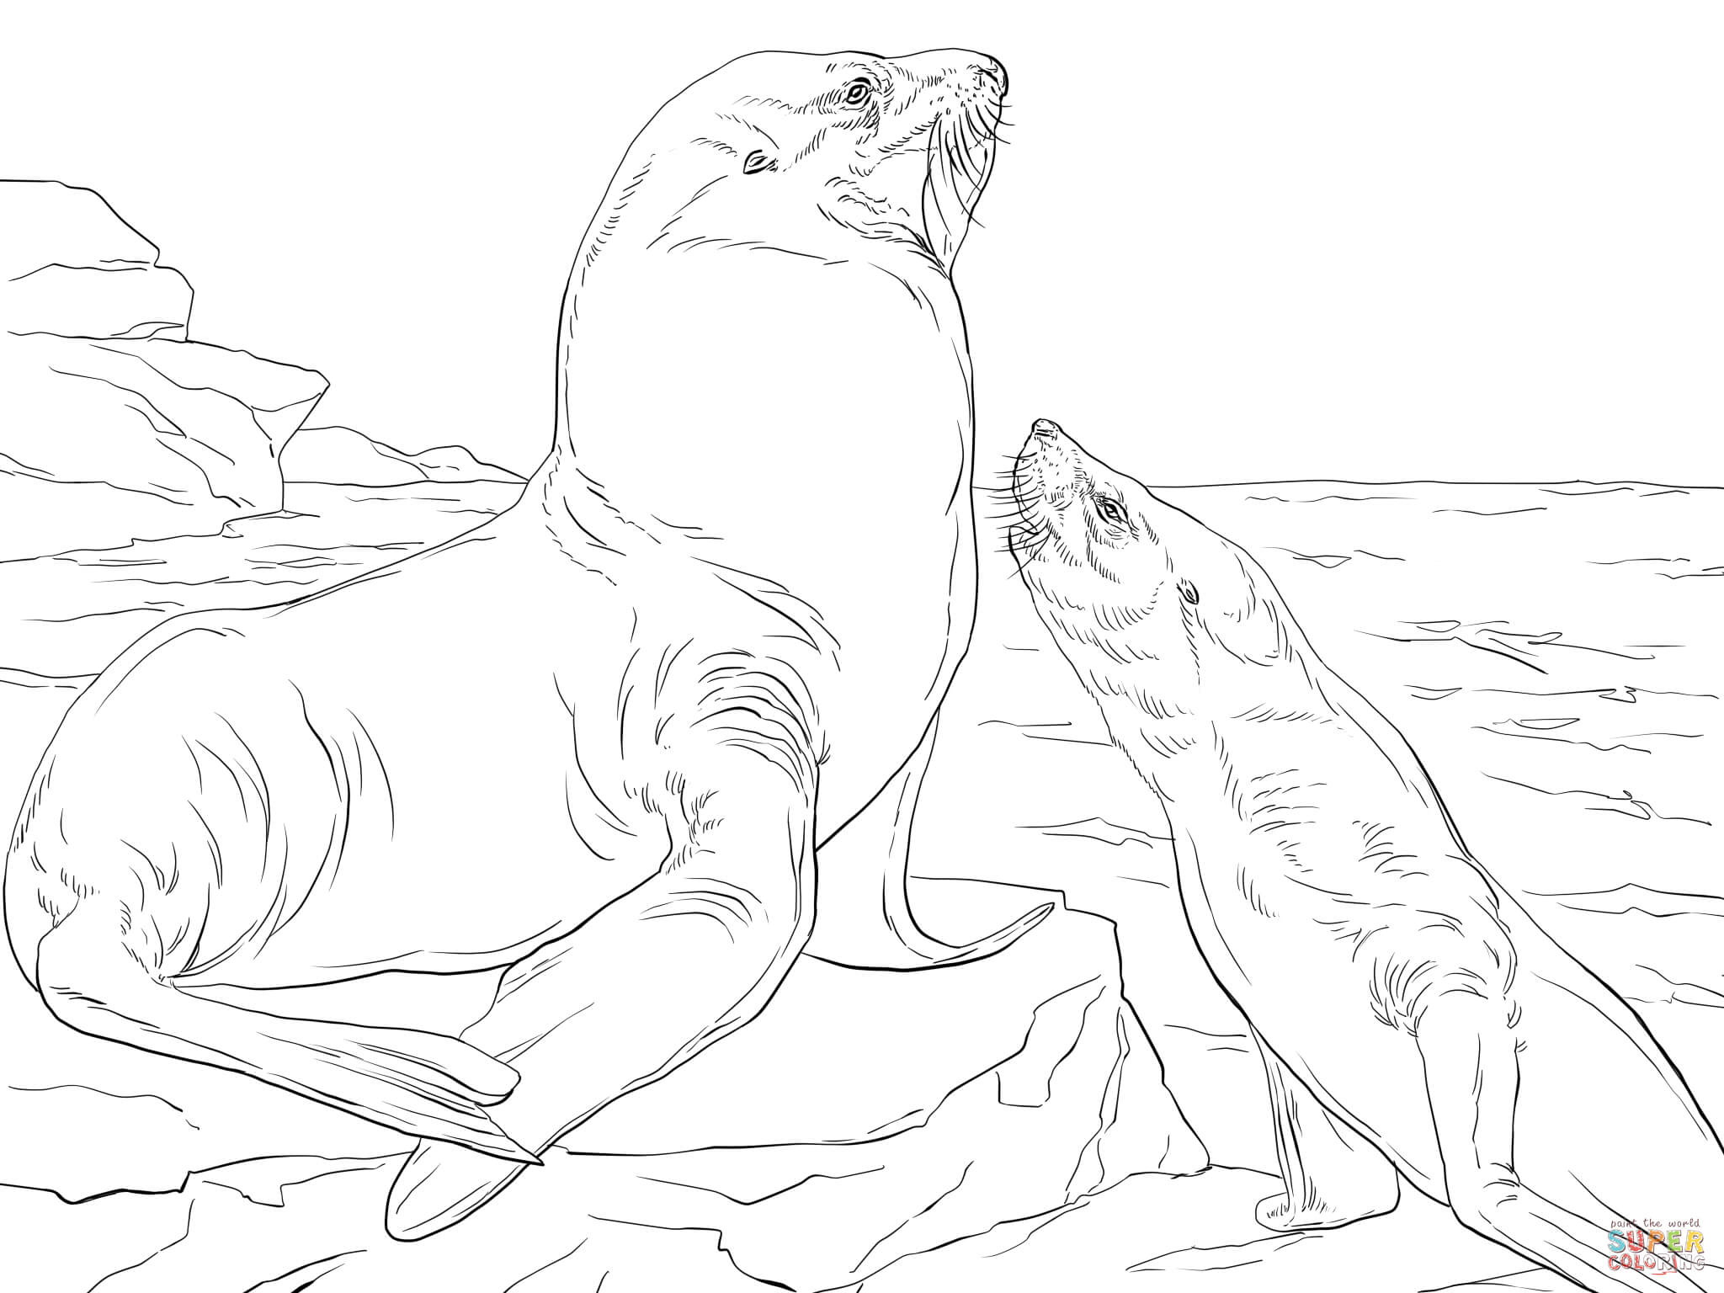 https://www.supercoloring.com/coloring-pages/steller-sea-lions?version=print
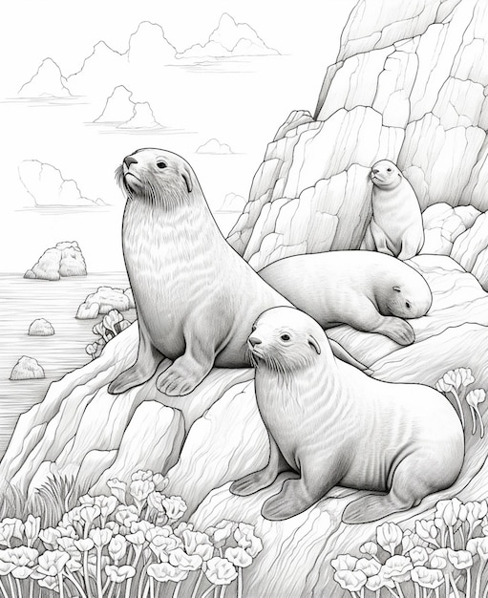

Premium AI Image | a drawing of a group of sea lions sitting on a rock generative ai (freepik.com)

