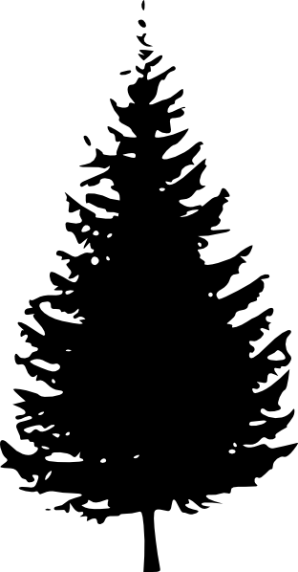
Name: _Anna Maria Ashley_
Grandparent: My Dad’s Dad’s name was Vernon Russell Ashley.
My Roots: Family Tree
Grandparent: My Dad’s Mom’s name was Reta Mae Tresierra.
Grandparent: My mom’s Mom’s name was Helen Dorothy Potter.
Grandparent:
My mom’s Dad’s name was Wilfred Allan Potter.

Parent: DAD

My Dad’s name is Marvin Allan Ashley.

Parent: MOM

My mom’s name is Bonnie Jean Ashley. Her maiden name was Potter.

Siblings: I have 3 younger brothers. Their names’ are Chester Norton Ashley, Samuel Nathan Ashley and Douglas Arthur Ashley.

My Mom’s side of the family | My Dad’s side of the family
Cultural Heritage  - My Mom’s Parents lived in Saskatchewan.  - She was born in Prince Albert, Saskatchewan.  - On my Grandpa’s side we have traced our ancestors back to England, and Scotland.  - On my Grandma’s side we have traced our ancestors back to Ireland, Prussia, and Germany.  - There are some other places but I’m not sure where.  - I don’t really know much about the cultural traditions of my English, Scottish, Irish, Prussian or German Ancestors.  - I would like to learn more about what traditions and customs were important to my ancestors. | Cultural Heritage  - My Dad’s parents lived in British Columbia.  - My Dad was born in Williams Lake, BC.  - On my Grandpa’s side we have traced our ancestors back to England, France, and some other places in Europe but I’m not sure where.  - On my Grandma’s side we have traced our ancestors back to Spain, and also to indigenous heritage in Secwepmec territory (Shuswap) and Nuuchahnulth (Nootka).  - My great Grandpa Charlie was born on the Sugar cane Reserve in Williams Lake.  - My Dad is an associate member of the Williams Lake Indian Band.

My Roots and Routes have shaped the person I am today because I have been brought up to value my family and my connections with them. I feel proud of who I am and what I have done with my life. I also feel that there is still a part of me that is missing because of not knowing about both my indigenous heritage and my settler heritage. I know very little about the indigenous part of my heritage and would like to learn more about both the Secwepmec and Nuuchahnulth nations traditional customs and way of life before Europeans came and what things are like now. I really want to learn more so that I can feel more connected with my ancestors.

Name: Anna Ashley
My Routes: How did my family get to Prince Rupert? Draw your route.
(use one colour for your Mom’s side (Blue) and one for your Dad’s side(Red) ) I am purple.
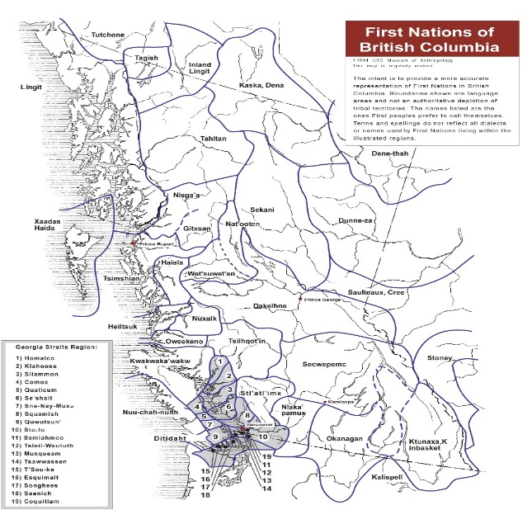
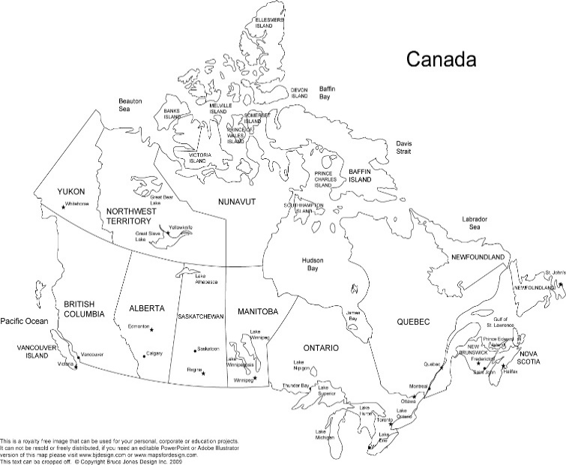
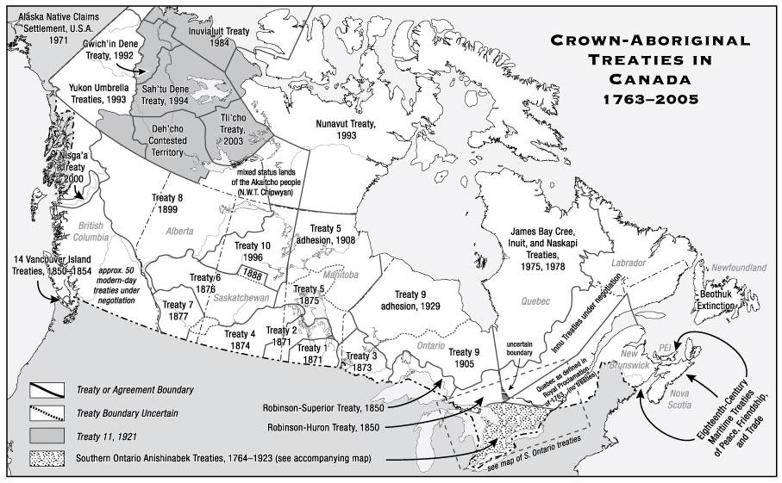
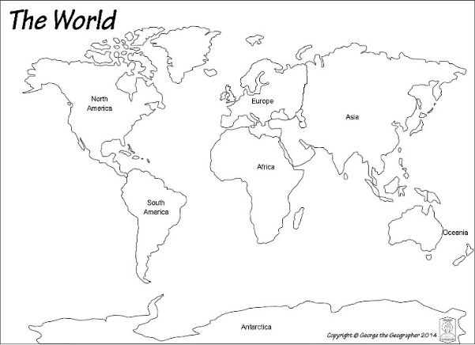
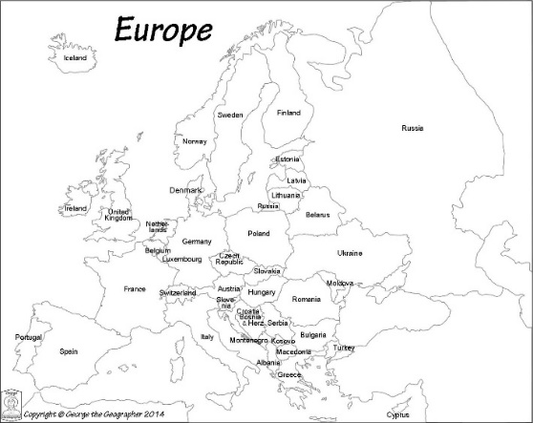
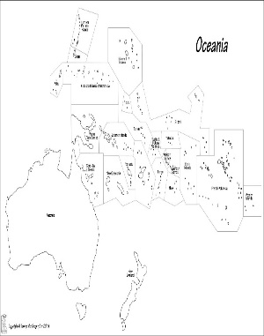
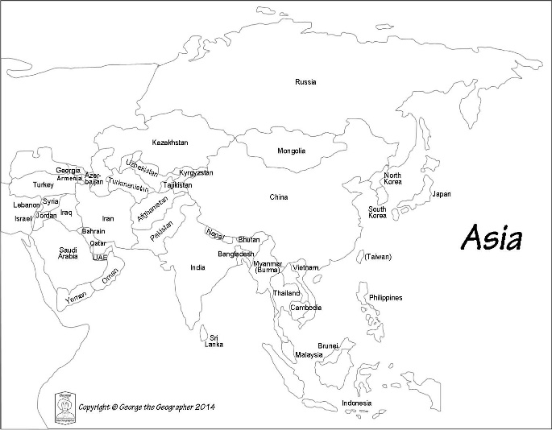
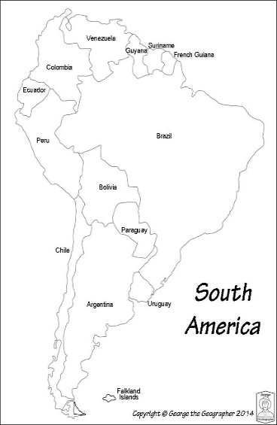
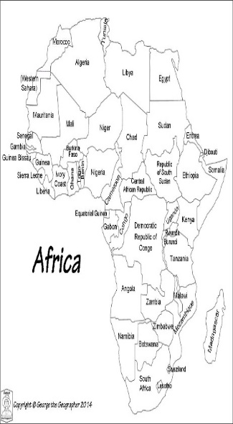
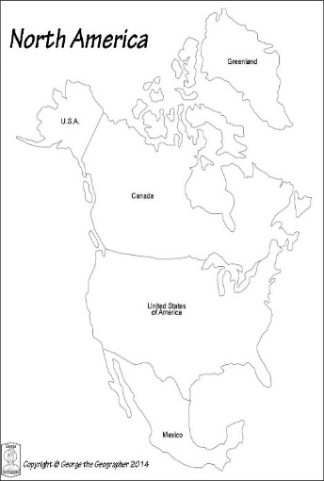
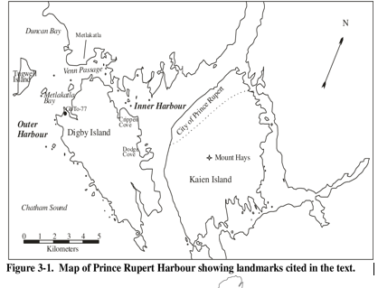
Grandma Ashley’s ancestors
Grandpa Ashley’s ancestors
Grandpa Potter’s ancestors
Grandma Potter’s ancestors
Grandma Ashley’s ancestors
My Grandparents on my Mom’s side
My Grandpa on
my Dad’s side
My Grandma on my Dad’s side
Me

