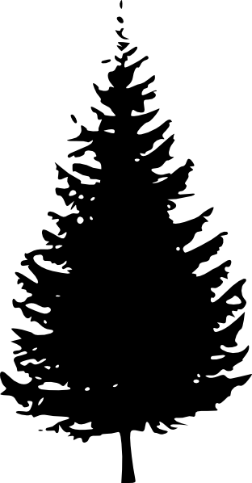
Name: _____________________________
Grandparent:
My Roots: Family Tree
Grandparent:
Grandparent:
Grandparent:

Parent:

Parent:

Siblings:

My Mom’s side of the family | My Dad’s side of the family
Cultural Heritage | Cultural Heritage

My Roots and Routes have shaped the person I am today because __________________________________
_________________________________________________________________________________________
_________________________________________________________________________________________
_________________________________________________________________________________________
_________________________________________________________________________________________

Name: ___________________
My Routes: How did my family get to Prince Rupert? Draw your route.
(use one colour for your Mom’s side and one for your Dad’s side)
