There are traditional Saulteaux words from Treaty Six Territory Mabel’s Feather.
Do your best to pronounce these words phonetically, with the /i/ making an /ee/ sound.

Saulteaux Word Glossary- Pronounce Phonetically.

~Apin- Sit
~Oma be une- wait here/ attends ici
~A Was- get out of here/ go away/ vas-t-en
~Ki goh moh gwain- don’t cry/ ne pleure pas
~Gi sah gee in- I love you/ je t’aime
~Kookoom- Grandma/ Grand-maman

Ideas/ Questions for Discussion

K-3
1. Have you ever lost your favorite toy or stuffed animal before? How did that make you feel?
2. Have you ever asked a grown-up who was supposed to help you and felt ignored? How did that make you feel?
3. Have you ever lost a person in your family?
4. Have you ever missed your mom or dad while at school?
5. Do you think the feather in the story is only a feather?
6. If you were in Mabel's story, what would you do to help her?

4-7
1. Talk about the metaphor in the story.
2. How does the author relate the missing mother to the feather?
3. Why do you think she used a feather instead of talking about the mother directly?
4. What does it mean to be validated?
5. What is invalidation?
6. Speak about the resources that went into Gabby Petito and how the media coverage put pressure on law enforcement. Why is media coverage so much greater for Gabby than for MMIW?

Websites:

https://www.nativehope.org/missing-and-murdered-indigenous-women-mmiw

https://www.nwac.ca/wp-content/uploads/2015/05/Fact_Sheet_Missing_and_Murdered_Aboriginal_Women_and_Girls.pdf

https://www.alberta.ca/red-dress-day.aspx

https://indigenousfoundations.arts.ubc.ca/about_the_redress_project/

https://www.jaimeblackartist.com/exhibitions/

Red Dress Day

Get a feather template from Google that you like, or use the clip art I have pasted below. Have students decorate the feathers in theme with the red dress and build the feathers into a dress. We researched Indigenous Art and spent our Art Class making these. Next, I Laminated ours and hung them on our fence to tie in with the REDress Project.
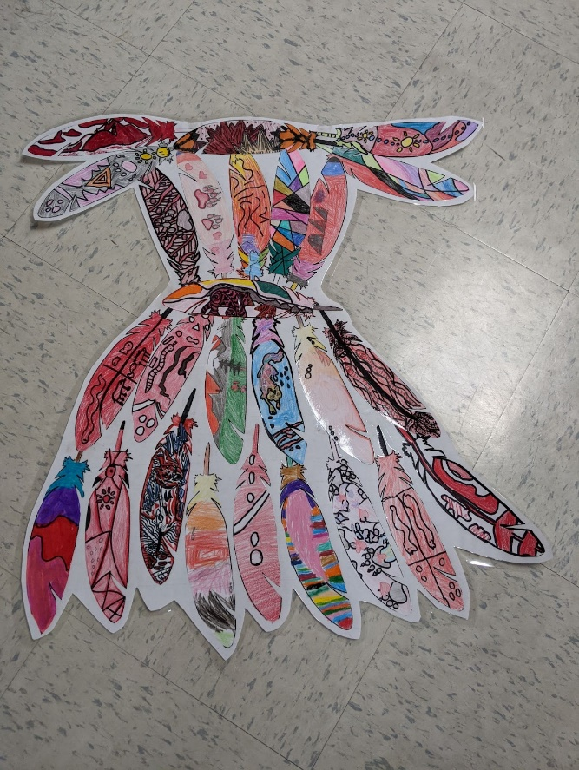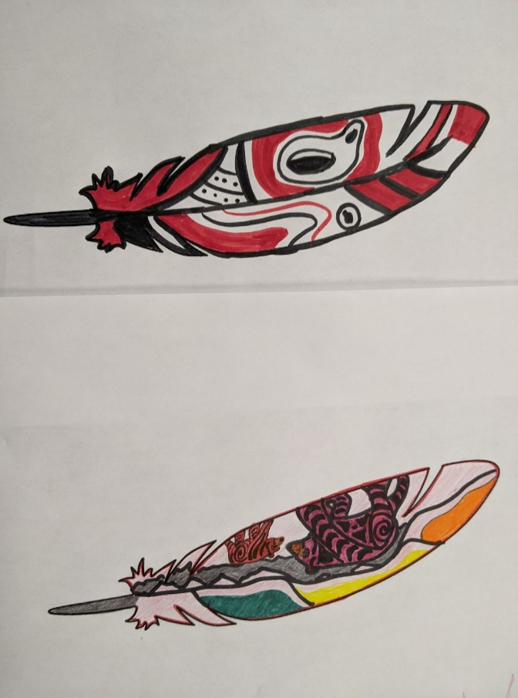
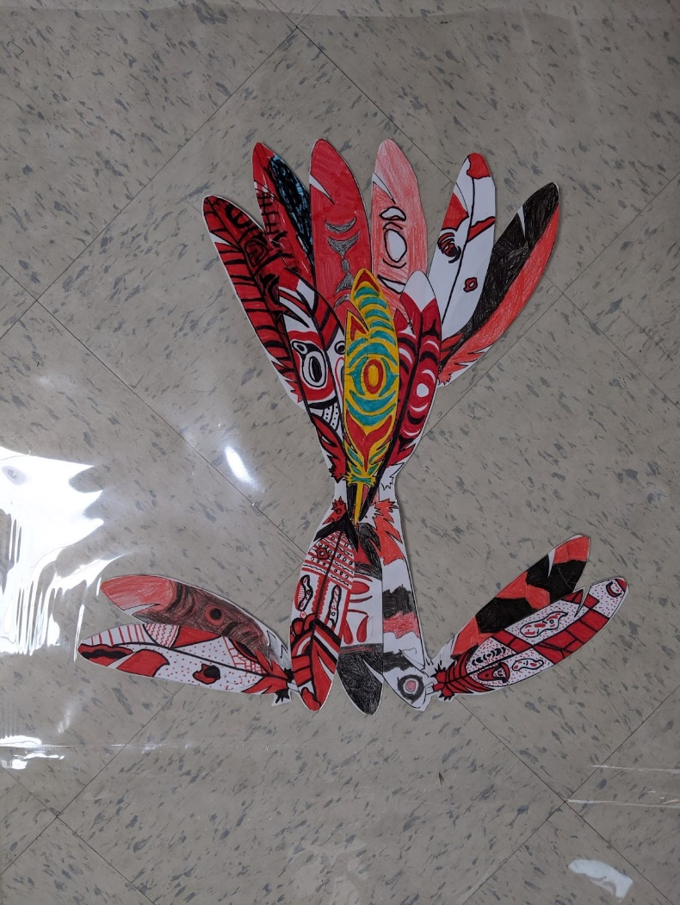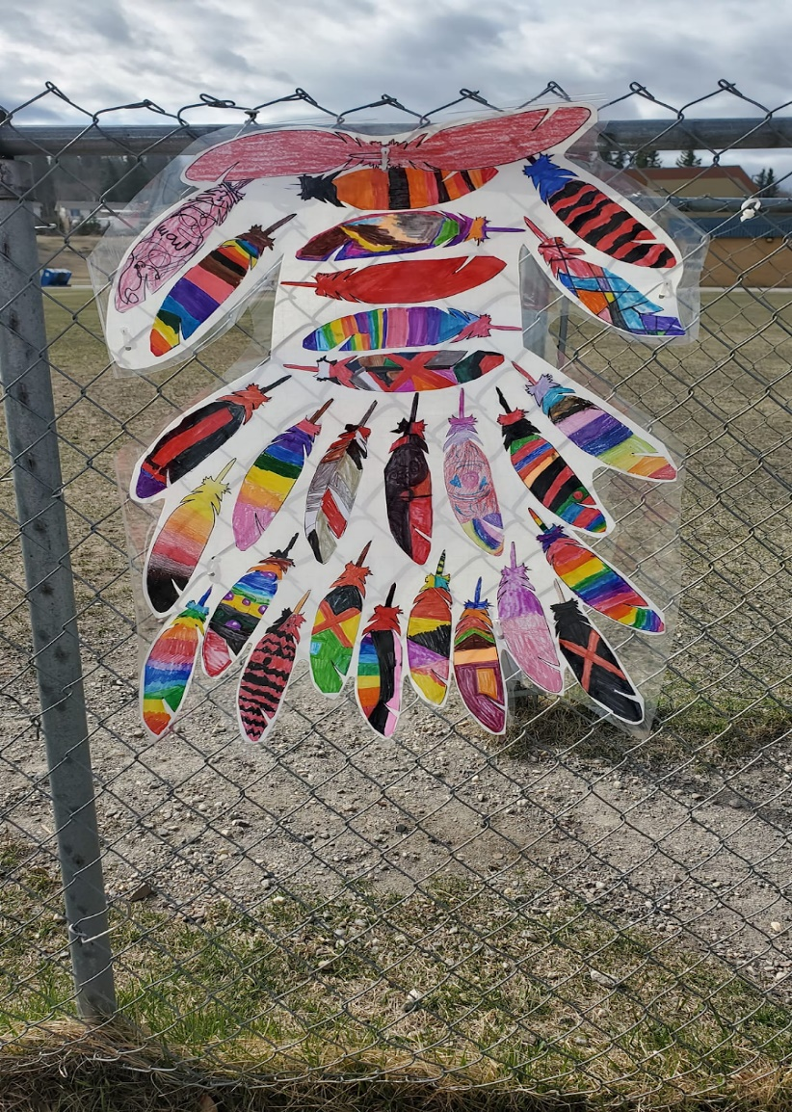

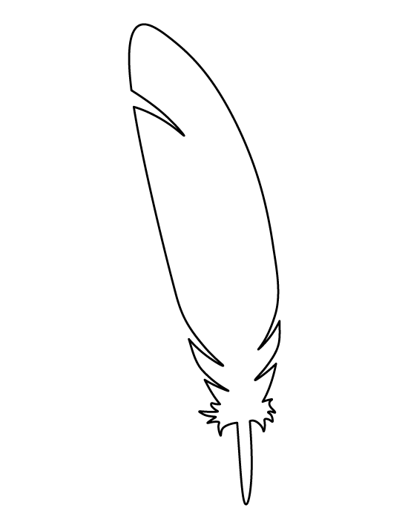
https://patternuniverse.com/download/feather-pattern/

