English 9 –Poetry Anthology Booklet and presentation
In this project you will be creating a poetry anthology booklet about poems/songs you like/enjoy. In this booklet you must complete the requirements for the grade you wish to receive. Your booklet must have the following:

Assignment requirements

General – Everyone must have the following in your poetry booklet for each poem/song you include.

- A title page with the title of your anthology, illustrations relating to the poems you have picked/written, your name, and your class on it.
- Table of contents with the names of poems and poets, as well as page numbers in the booklet.

Specific –

- You must have include the following number of poems/songs written by someone else.
  - To get a C- you must have 5 poems written by someone else.
  - To get a C you must have 6 poems written by someone else.
  - To get a C+ you must have 7 poems written by someone else.
  - To get a B you must have 8 poems written by someone else.
  - To get an A you must have 9 poems written by someone else.

- You must include the following number of poems/songs written by you.
  - To get a C- you must have 5 poems written by you.
  - To get a C you must have 6 poems written by you.
  - To get a C+ you must have 7 poems written by you.
  - To get a B you must have 8 poems written by you.
  - To get an A you must have 9 poems written by you

- For each poem/song in your booklet you include the title, and the poets name.

- For each poem/song in your booklet you must explain why you chose or wrote the poem.

- For each poem/song you must include the following number visuals/pictures to represent the images in the poem and explain why for each image. (ie. What in the poem/song made you think of that visual/picture?)
  - For C- you must have one visual or picture with an explanation per poem/song.
  - For C/C+ you must have two visuals or pictures with an explanation for each per poem/song.
  - For B/A you must have three visuals or pictures with an explanation per poem/song.

- You must answer the following set of questions for half of the poems in your booklet.
  - What is the poem about?
  - What is the theme of the poem? Explain how the theme is shown in the poem.

To get a higher grade-

- To increase your chance or receiving a higher grade you must present one of your poems to the class from your booklet. In this presentation your must do the following:
  - Show, play or read the words of your song/poem.
  - Share the title of the poem and the poets name.
  - Summarize what the poem is about.
  - Explain your visuals and where you got them from in the poem.
  - Explain the theme of your poem.

Poetry project checklist

Do I have a title page that has a title, my name, my class, the period, pictures and the date?

Do I have a table of contents with the pages for each poem and the names of the poems as well as the poets?

Have I explained why I chose/wrote each poem?

Do I have at least 5 poems written by someone else or more if I want a higher grade?

Do I have at least 5 poems written by me or more if I want a higher grade?

Have I included the title of the poem and the name of the poet for every poem?

Have I included at least 1 visual for each poem (more if I want a higher grade) and explained what it was in the poem that made me think of that visual?

Have I summarized what each poem is about?

Have I explained the theme/message of each poem?

If I want a higher grade have I prepared all of the elements I need to present one poem in my booklet including the title, name of poet, summary of poem, theme of poem, explanation of visuals, and chosen a way to share the words in my presentation?

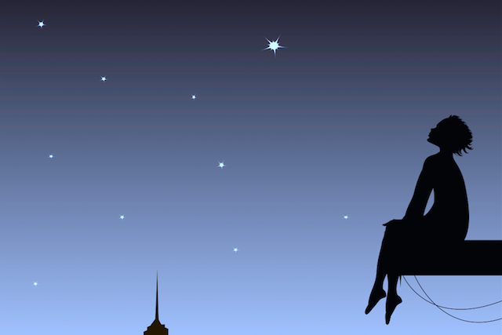
Title Page Example

POETRY ANTHOLOGY BOOKLET
Poems that Inspire Me
NAME
ENGLISH 9
PERIOD
DATE

A Time To Believe by B.J. Morbitzer  To believe is to know that  every day is a new beginning.  Is to trust that miracles happen,  and dreams really do come true.  To believe is to see angels  dancing among the clouds,  To know the wonder of a stardust sky  and the wisdom of the man in the moon.  To believe is to know the value of a nurturing heart,  The innocence of a child's eyes  and the beauty of an aging hand,  for it is through their teachings we learn to love.  To believe is to find the strength  and courage that lies within us  When it's time to pick up  the pieces and begin again.  To believe is to know  we are not alone,  That life is a gift  and this is our time to cherish it.  To believe is to know  that wonderful surprises are just  waiting to happen,  And all our hopes and dreams are within reach.  If only we believe.  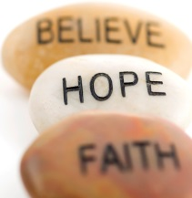  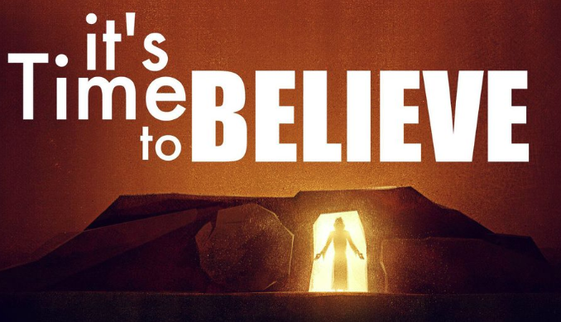 | Poem: A Time to Believe  Poet: B.J. Morbitzer  Topic: Motivational poem  - I chose this poem because it talks about what it means to believe in something and I think that you must believe in what you are doing to be motivated to do something. For example, if a person believe they can make the world a better place, by improving the environment, for instance, then they are more likely to be motivated to take action to accomplish their goals.  - This poem is about the power of believing. It gives examples of what it means to believe in something, and how we can reach our dreams if we believe in something.  - The theme of this poem is that if you believe in something enough you will have the power to make your hopes and dreams come true. For example, it talks about how when people believe, they can “trust that miracles happen” and they can “find the strength and courage that lies within.” Since belief allows for us to imagine the possibilities in life, it helps us succeed in fulfilling our hopes and dreams.  - One visual I chose for this poem was a picture of an angel surrounded by clouds because in the second stanza it describes an angel dancing in the clouds, which made me think of an angel floating in the clouds, dancing from cloud to cloud. Another visual I chose was a star filled with night sky because in the poem it talked about stardust, and this made me think of a star filled with twinkly stars. The third visual I chose was a heart with a picture of a kid inside because it talks about a nurturing heart and an innocent child, so this made me think of a heart and an innocent looking kid with wide eyes.
Poetry Anthology Booklet poem page example

