Course: English 9 B Teacher: Miss Ashley Year: 2019-2020

English 9 B: Poetry and Drama focus : Course Outline

The focus of English 9 is on proper grammar, writing, and literature study. Subject areas that we cover include: short stories, novels, drama, creative writing, poetry, first nations literature, grammar, sentence and paragraph structure, essay writing, technical reading and writing, spelling, vocabulary, and oral speaking. These will be used in conjunction with the curricular competencies and content for the course. In this course you will be expected to develop an understanding of these study areas and demonstrate your knowledge in assignments, essays, reports, presentations, quizzes, tests, and exams. Assessment will be based both on oral and written knowledge of these areas.

Due to our new trimester system English 9 has been broken up into two sections. Part A focuses on novels and short stories and Part B focuses on poetry and drama. Various forms of composition will be explored in both sections.

The new curriculum consists of core competencies, which are sets of intellectual, personal and social and emotional proficiencies that all students need to engage in deep learning and life-long learning. These core competencies will be incorporated throughout the course. For English 9 these core competencies are:

- Communication -The communication competency encompasses the set of abilities that students use to impart and exchange information, experiences and ideas, to explore the world around them, and to understand and effectively engage in the use of digital media.

- Thinking - The thinking competency encompasses the knowledge, skills and processes we associate with intellectual development. It is through their competency as thinkers that students take subject-specific concepts and content and transform them into a new understanding. Thinking competence includes specific thinking skills as well as habits of mind, and metacognitive awareness.

- Personal and Social - Personal and social competency is the set of abilities that relate to students' identity in the world, both as individuals and as members of their community and society. Personal and social competency encompasses the abilities students need to thrive as individuals, to understand and care about themselves and others, and to find and achieve their purposes in the world.

The curricular competencies and learning outcomes for English 9 focus on 6 big ideas which are as follows:

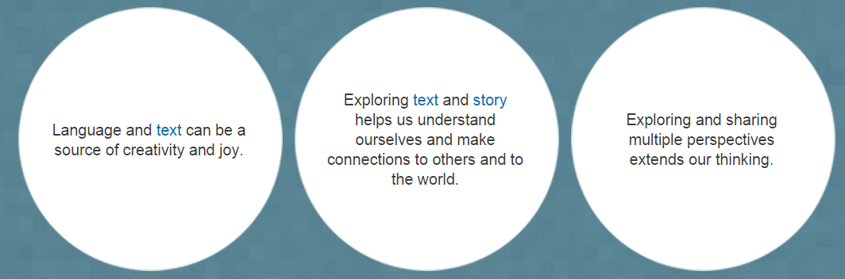
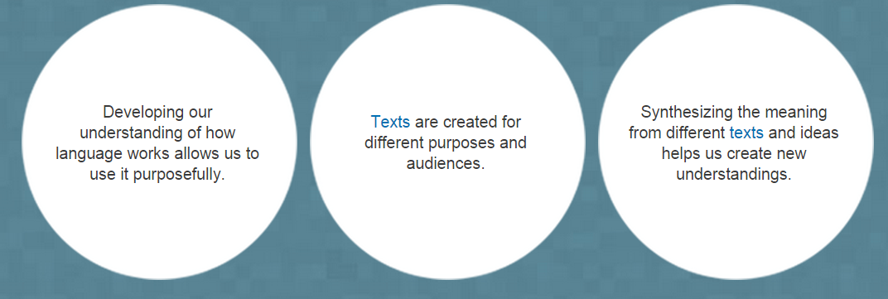

Curricular Competencies

In addition to core competencies each curriculum has a set of skills that they are expected to be able to do and a series of content they are supposed to study to achieve competency in those skills sets. In English 9 students these are the learning standards:

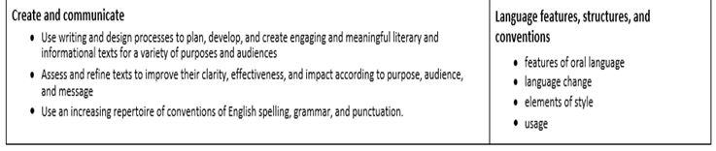
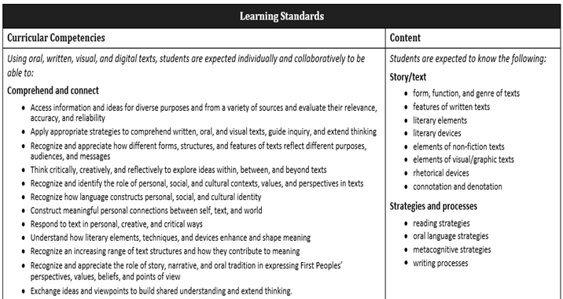

For this course there are certain things you will need. These are as follows:

Books needed:
These will vary as the year progresses. The first books you will need will be discussed in the first week.

Supplies needed:
You will need the following supplies-2 pens (one dark blue or black and one red or green), pencil, eraser, 30 cm ruler, lined paper, blank paper, graph paper, 2 packages of subject dividers, a thesaurus, a dictionary, pencil crayons, scissors, glue stick, white out (liquid paper), 3 ring binder (1 ½ to 2 inches). You should also have a flash drive for sharing work done on the computer. If other supplies become necessary you will be informed. It would be useful for you to start saving old magazines for projects we will be doing throughout the year.

Evaluation: Assignment evaluation will be based on the curricular competencies as listed above with relation to the content in the course. Various methods of assessment will be incorporated into each students evaluation including self-assessment, portfolio, rubrics, formative assessment (assessment for learning), and summative assessment (assessment of learning) etc.

Breakdown of course work in the context of evaluation

Your course work will be evaluated using portfolio assessment and a final presentation of learning. Practice work, assignments, course work, quizzes and tests will be compiled throughout the year and then assessed as a whole based on the curricular competencies to determine your final course mark. Below is a description of the evaluation tools. Assessment will be based on the learning outcomes using performance standards as a guideline. All evaluation will be based on the curricular competencies for each content area of the course. This evaluation will be cumulative and will be continually reassessed as skills improve. Formative, summative and self-assessment will be parts of each of these aspects.

Preparation & Practice- This section will also consist of assignments that allow them to practice and prepare for final evaluation of their skills and abilities. This allows students to practice skills before final evaluation occurs. Self -evaluation and peer editing will be an important component of this mark based on performance standards and assignment rubrics. Being prepared for lessons and discussions will also be considered. Discussions and oral work are included as well. Students will be given descriptive feedback that they will be expected to apply to their work as they are learning.

Assignments and Course Work-This consists of writing assignments, classwork, projects, research reports, essays and presentations throughout the term.

Quizzes / Tests / Exams-This consists of quizzes, unit tests (based on one unit of study), and exams (based on several units of study).

Final Presentation of Learning-This will be a final project comprised of a series of assignments/projects and/or written/oral tests that compile an overview of the majority of learning outcomes.

Other things to remember:

Please let me know if you are having difficulties with your studies and arrange for help either during or outside of class time. Students are responsible for catching up on missed work. They should establish one or two people in the class with whom they can find out what they have missed If students are going to be away they should let the teacher know as far in advance as possible. If possible and feasible, work will be given for the time they are away however, there is no guarantee. They may need to catch up on this work when they come back. It should also be made clear that missing too much class time will have a detrimental effect on a students’ chance of success in class.

Students are expected to hand in whatever they have done for when an assignment is due. The assignment will then be marked based on what is handed in. It is not an option to not submit an assignment. As stated, students will be expected to hand in whatever has been completed at that point. The only exception to this will be if there are valid reasons for the assignment not being handed in by the required time.

If a student hands in an incomplete assignment at the time it is due, they will no longer be able to complete that assignment. In this event, it is possible for an alternate assignment to be given to students that would allow the student to demonstrate their competency in the required learning outcomes. Alternate assignments may or may not be evaluated on a pass/fail basis. This will depend upon the circumstances and the learning outcomes involved, as well as the reason for why the assignment was incomplete. NOTE: Alternate assignments will also have deadlines that will be expected to be followed. If, after being given the chance to do an alternate assignment, the student still does not complete the work assignment they will have to hand in what they have done and be marked accordingly as being incomplete and/or not meeting expectations for the learning outcomes.

All students writing assignments must follow the writing process and include evidence of their work, including brainstorming, notes, outlines, rough drafts, editing and of course, their good copy. If these steps are not followed the student it will be considered incomplete and it will be up to the teacher’s discretion as to whether the student will be allowed to redo the assignment or complete an alternate. In addition, not completing all of the steps will result in a lowered mark for the assignment as all steps are part of the learning outcomes being evaluated.

Enrichment work:

Should a student wish to do further study in a particular area related to Social Studies they may speak with the teacher and submit a proposal for their study initiative. Please note that this type of assignment would not be considered bonus work, but rather, a chance to improve a student’s grades by having the chance to submit projects/assignments done at a high level of achievement in relation to curricular competencies. These marks would then be added into the overall mark scheme for final evaluation based on the learning outcomes under the curricular competencies.

Last note: I am requesting a valid parent email address so as to make communication quicker and more efficient. If your parents do not have an email address please bring your current home contact numbers to school. I have your student school email that I will use to send you information but if you do not want me to use your school email, please email me your preferred email address, so I can forward handouts and assignments to you. My email address is aashley@sd52.bc.ca . If for some reason this does not work you can also send it to my personal email sportyrupertgirl@hotmail.com . Please only do this after trying the school email first. This is the easiest and best way to contact me. Please let your parents know that email is the quickest and most efficient way to get in touch with me. However, if they need to phone, please phone my home phone number and leave a message, rather than phoning the school. My home number is 250-624-5492. We do have voice mail boxes at the school but it is much quicker and easier to simply leave a message on my phone at home. You can also keep track of many class handouts, assignments and helpful links on my website: aashley.weebly.com and then looking for the link to this class, however please note this is not updated daily, so if you cannot find what you are looking for please email me and I will be happy to assist you.

PLEASE REMEMBER REGULAR ATTENDANCE IS CRUCIAL TO YOUR SUCCESS IN CLASS!

