Mindful Educational Brain Breaks

1. Use transition times for mental check-ins
Transitions are a big part of the elementary school day. When I first started teaching 19 years ago, I was surprised by just how much time it takes to get ready for specials or to bring students back from centers. It’s hard not to feel like that’s lost time. That’s why using transition time for mental health check-ins is such a game changer. Mental health check-ins can help students get in touch with their emotions, refresh and recharge, acknowledge and cope with negative thoughts and overwhelming feelings, and be more focused throughout the day.

2. Pretend to breathe like an animal
Source: Stephanie Sanders
This video shows students how to pretend to breath like some of their favorite animals. The snake breath involves hissing while slithering from side to side, while the whale breath has students pretend to breathe out through a blowhole! Tap into creativity by picking other interesting animals and acting them out through breath.
ADVERTISING

3. Do a 10-minute guided meditation

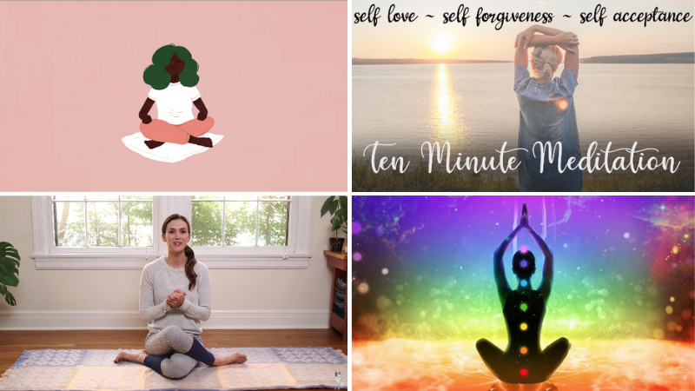
ADVERTISEMENT
These guided meditations are educational and are perfect to use as brain breaks whenever you and your students just need to breathe. Catch your breath with any of these 20 guided video meditations.

4. Practice “focus ball” breathing
Walk your kids through the following exercise: Stand or sit with legs and feet together. Bring your palms together in front of your chest. Keep your fingertips touching as you pull your palms apart, forming a ball with your fingers. Press your fingertips together until you feel the muscles in your hands and arms activating. See if you feel your core tighten too. Now close your eyes and as you breathe in, inflate your ball, and as you breathe out, flatten the ball by pushing your palms together. (Repeat these instructions for 60 seconds).
Learn more: Mindful.org

5. Try the old ear-nose switcheroo
This is a quick and easy challenge to reset the brain. Instruct kids to touch their left ear with their right hand and at the same time touch their nose with their left hand. Then have them switch their hands and touch their right ear with their left hand and their nose with their right hand. Switch back and forth a few times. Then have them close their eyes, take a deep breath, and blow it all out.
ADVERTISING
Learn more: YouTube: Ear-Nose Switch

6. Take a yoga break
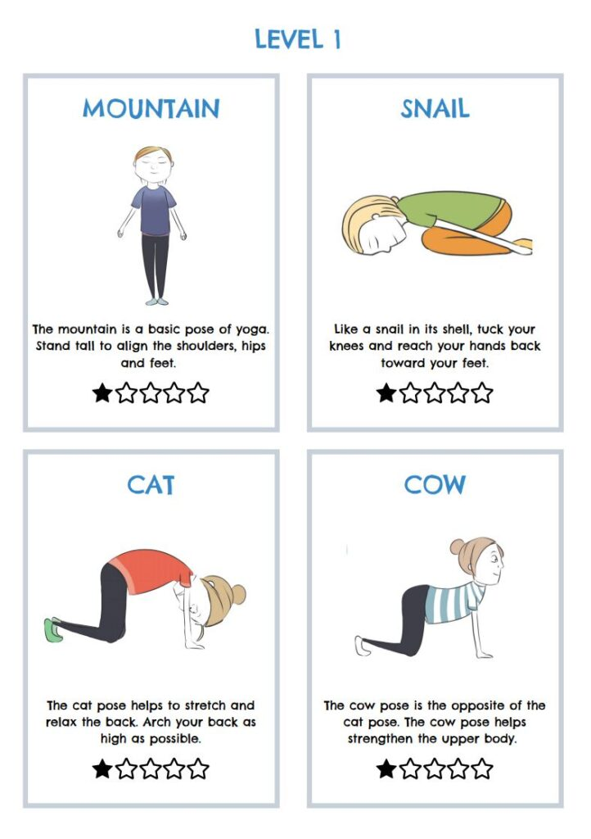
Source: The Pyjama Foundation
Inspire kids to move, stretch, and practice mindfulness with yoga. These printable yoga cards make it easy to incorporate yoga into your educational brain breaks. Each page includes a picture and description of the pose, and each page includes poses of increasing difficulty from level 1 to level 5. And don’t worry, it’s not a huge time commitment. The sequence on each card is designed to take only a few minutes.

7. Stretch it out
It’s never a good idea to spend too much time sitting in one position. Allow kids to take a break and bring some flexibility back into their spines. Have them stand with their feet shoulder-distance apart. Put their left hand on their hip and raise their right hand overhead. Lean to the left and stretch their arm as far as they can to the left. Repeat on the right side. Then stand tall and slowly roll down one vertebra at a time until their hands reach the floor (or at least their shins). Have them take a deep breath then slowly roll back up. Repeat as necessary.
Learn more: Mom Junction

8. Focus on sound
Have kids sit quietly with their eyes closed. Ring a chime or gong. Have them listen carefully to the chime, feeling the vibration in their body as the sound reverberates and then slowly fades. Tell them to breathe slowly and deeply as they focus on the sound.

9. Do a quick mindfulness activity
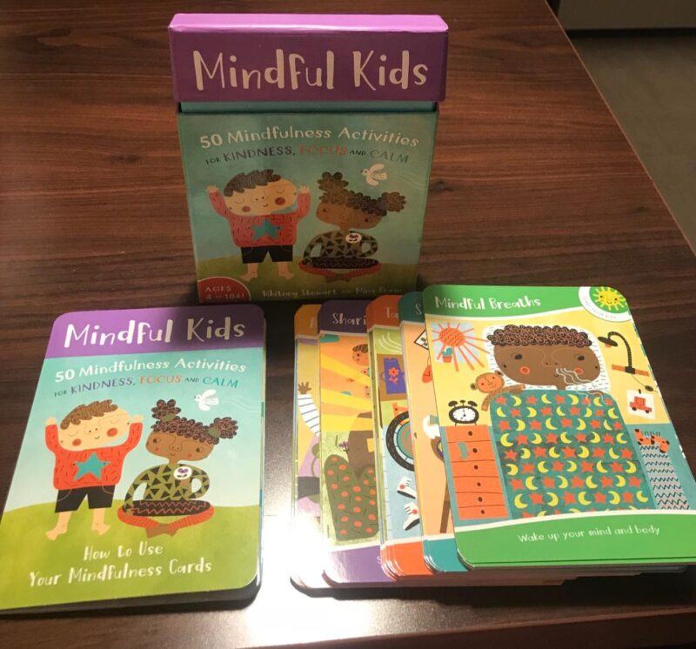
Mindfulness activity cards provide great educational brain breaks. Stash a pack in your desk and pull them out whenever you need them. Each card will give a prompt for kids to try that will let them refocus and recharge. Perfect for moments when you need to bring down the energy in the room.
Buy it: Mindfulness Cards for Kids at Amazon

10. Chill out with this cross-body exercise
Have kids stand tall and cross one leg in front of the other while pressing the outsides of their feet together. Now have them cross their arms over each other at the wrists. Clasp their hands and curl their arms into their chest. Take a few breaths, and uncross and cross the opposite way for a few more breaths.

11. Float with jellyfish
When you really need to take the energy in your room down a notch, turn off the lights, set a timer, and put on a calming video. For example, Cat Trumpet put together a jellyfish aquarium video where kids will find themselves under the brilliant blue sea in the middle of a swarm of jellyfish. They’ll be mesmerized by the slow, fluid motions and lulled into calmness by the soothing music.

12. Break out the hot hands
This is a good break when you sense a weariness in the air. Have kids rub their hands together vigorously until they warm up. Tell them to close their eyes and place their hands over their eyes. Instruct them to breathe deeply as they clear their minds and refocus.

13. Try cat and cow poses

Source: Flow and Grow Kids Yoga
Have kids start on all fours and then give them the following instructions to complete the cat and cow yoga poses: Place your shoulders over your wrists and hips over your knees. Arch your back to the sky and tuck in the tailbone (cat pose). Let your head fall between your arms. From there, sink the belly towards the ground, and lift the chest and chin (cow pose). Gently alternate between the two poses while breathing deeply.

14. Do nothing for two minutes
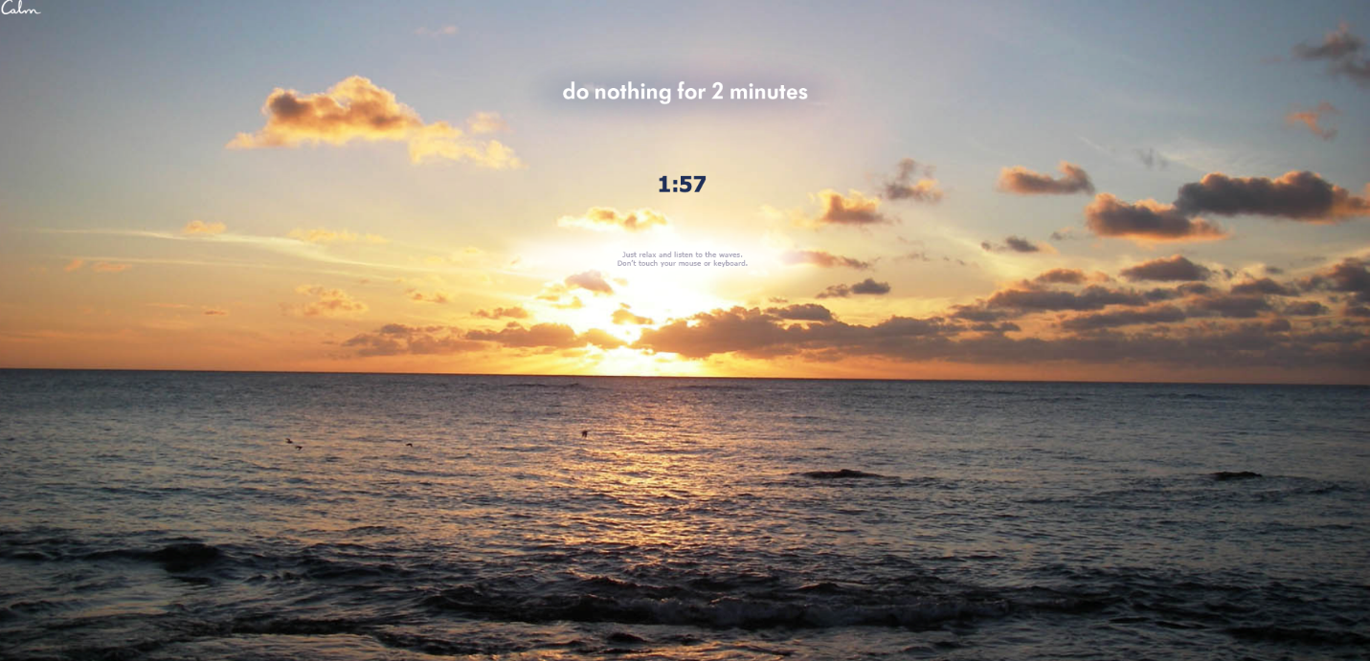
Never underestimate the power of stillness. When the energy gets a little ramped up, and it’s time for the entire class to take a pause, have them drop everything and glue their eyes to the screen as you show this countdown. The gentle lulling of the waves and the sight of the sun sparkling off the water will reset their nervous system in a jiffy.
Learn More: Calm
ADVERTISING

15. Spread your wings (in slow motion)
Walk your kids through this winged movement: Sit cross-legged on the floor. Stretch your arms down by your sides with your palms facing inward toward your body. Slowly raise both arms while rotating hands forward. When your arms reach shoulder level, your hands should be facing forward. Continue raising arms, slowly rotating palms so that by the time hands are overhead, palms are facing each other. Slowly lower arms, repeating the rotation (palms facing each other, palms facing forward, palms facing sides) until they are once again resting at your sides. As you raise and lower your arms, stretch them as long as you can, as if you are scraping the sides of the room and the ceiling. Repeat slowly three times, breathing deeply.

Physical Education Brain Breaks

16. Play Silent Ball when you have downtime
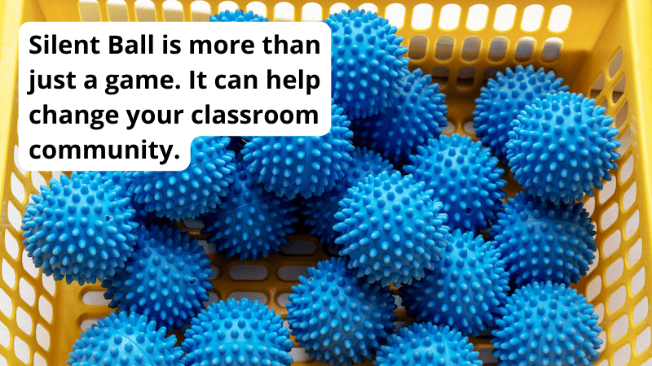
You can play a quick game of Silent Ball anytime, anywhere. Play a quick three-minute game right before dismissal or before transitioning to a new activity. All you need is a small squishy ball. The rules are simple: 1) stay quiet and 2) don’t drop the ball when passing it around. This activity is one of those educational brain breaks that builds a positive classroom community, fosters friendly competition, and boosts nonverbal communication. Enjoy the silence.

17. Line up in unique ways
Kids are very social and curious beings. Most of them love to chat with one another at any chance they can get. Lining up to leave the room for anything is the perfect chance for them to mix and mingle. Make a more productive use of this time by having students line up in special ways. Some fun ideas include lining up in alphabetical order by name, by birth date, or by height order.

18. Just jump!
Sometimes kids just need to bounce their energy out. Have them pretend they are bouncing on a mini-trampoline (this will keep their movement on a vertical plane instead of all over the room), and give them a couple of minutes to let loose!
ADVERTISING

19. Take a cue from the stadium
Here’s one for a group of kids—start the wave! Beginning at one end of the room, kids stand up and throw their arms overhead, bringing them back down as they return to their seats. Each row follows until you reach the other end of the room. Amp it up by encouraging your kids to tap their feet or tap their hands on their legs so that they are in constant motion. This activity works great on Zoom too!

20. Stir the pot
Have kids visualize they are standing in front of an enormous cauldron. Inside the cauldron is an ooey-gooey pot of caramel. Take hold of a large stirrer and plunge it to the bottom of the pot. Slowly begin to stir in a clockwise direction. Have them use their whole body to help get a full range of motion in their wrists and shoulders. Instruct them to throw their hips into the action. After a minute or two, reverse the direction.

21. Make it rain
Conjure up a rainstorm! Sitting or standing at a desk or table, have kids tap one finger on the desk, then two, then three, then four, then their whole hand until you all feel like you’re in the middle of a deluge. Work your way backward from five down to one as the storm ebbs away.

22. Energize with these
First, instruct kids to touch their left elbow to their right knee, then touch their right elbow to their left knee. Switch back and forth, going slowly at first, building speed until they are going at a vigorous pace. Next, do some windmills by standing tall with their feet shoulder-width apart and their arms stretched out. Bend at the waist and touch their right hand to their left toes, then their left hand to their right toes. Switch back and forth.

23. Make X’s and O’s
Walk kids through the following exercise: Sitting in a chair with your feet on the ground and legs together, curl your body into your lap, folding yourself into a tiny O shape. Next, open your arms and legs wide, forming an X shape with your body. Pull back into an O shape, then back out to an X shape. Repeat three times.
ADVERTISING

24. Energize in 5, 4, 3, 2, 1
Get hearts pumping with a quick sequence of exercises. Call out five actions for your students to do as quickly as they can. For instance, five jumping jacks, four push-ups, three sit-ups, two squat jumps, and one tree pose.

25. Take a cruise on an imaginary skateboard
Have your kids line up next to a wall and place one hand on the wall. Tell them to plant the foot closest to the wall and swing the other leg, as if pushing off the ground on a skateboard. Start slowly, with tiny swings, moving up to power pushes. Repeat on the other side.

26. Take a break to groove
Music is a great way to reset the mood in a room and raise the energy level. Put on a fun song and have a 30-second freestyle dance party. Here’s a big list of school-appropriate songs for kids.

27. Or take it to the next level
Teach your kids the steps to popular dances such as the Cha-Cha Slide, the Macarena, or the Kidz Bop Shuffle.

28. Ramp up with a round of cherry pickers
This easy activity will get your students’ hearts pumping and give their brains a boost. Have them jump up off the ground, then down to the floor into a push-up position. From there, instruct them to hop their feet up into a frog position, then pop up to a standing position.

29. Clap on, clap off
When you say “clap on,” kids clap their hands vigorously together. When you say “clap off,” they stop as quickly as they can and freeze. Or follow along with this a fun video.

30. Skip it out
When the energy is fading and kids need to get their blood flowing, put on a peppy song and pull out the imaginary jump ropes. Have kids skip or jump rope in place until the song ends.

31. Make like a blender
Tell kids it’s time to make fruit smoothies. Ask them to pretend they are in a blender and they are strawberries (or blueberries or bananas, etc.). Dramatically pour orange juice or yogurt into the air in front of you. Tell kids when you flip the switch that they need to wiggle and jiggle (separately, not together) until they are each individually blended up. Start with a slow speed, moving up to medium speed, fast speed, and finally turbo speed. And then reverse it! Start at turbo speed and go back to slow speed.
ADVERTISING

32. Celebrate with a silent cheer
This activity is perfect for the end of an activity or a sustained amount of work time—especially for kids who are learning remotely. Let kids stand up and silently cheer and gesture in celebration. How animated can they get?!

33. Do a full-body workout
This kid-friendly exercise video is great for your body and brain! Kids can follow along through a set of workout moves that will get their blood pumping.

34. Play popcorn
Students will all be sitting in their chairs, and at any time, a student can jump up and say, “Pop!” Once they do, that student remains standing. If two students pop up at the same time, everyone takes their seats, and the game starts over. How quickly can the entire class pop without having to start over?

35. Hit the wall
Pushing against a solid object is a good way to displace extra energy from your body. Have kids stand facing a wall with their arms stretched out in front of them, palms on the surface of the wall. Push the wall away with all their strength for a count of ten. Relax for five seconds, then push again. Other activities they can do at the wall include calf stretches and wall push-ups.
ADVERTISING

36. 3, 2, 1 blastoff!
Instruct kids to stand and then squat down with their hands on the ground in front of them. All together, count down 3, 2, 1. When you get to zero, they should push up like a rocket, jumping as high as they can—letting all of their energy burst from their center.

37. Quick as a snap, wink
This is a quick and easy refocusing activity. Tell kids to snap their left fingers while they wink their right eye. Switch to snapping their right fingers while winking their left eye. This activity is particularly effective for younger learners who may find both activities challenging.

38. Balance break
A great way to get kids out of their chairs is to practice balance. Have them hop on one foot. Then up the ante by having them stand on one foot and bend their other knee out in front of them.

39. Tabletop push-ups
Kids can use their desk, a chair, the side of their couch—anything really. Have them place their hands on the table and focus their eyes in the center, moving down slowly and pushing back up.

40. Try some facial gymnastics
Have kids get their silly on for 30 seconds. Tell them to wiggle their eyebrows up and down as fast as they can. Then try to raise one eyebrow at a time.

Mental Brain Breaks That Are Educational

41. Take a comedy break
Comedy is a great release when the atmosphere is feeling a little intense. Show a funny video clip or have kids volunteer to tell a joke or pose a few silly riddles. We have compiled a number of jokes by theme on WeAreTeachers for kids of all ages for guaranteed laughs. For example, your students will love one of our most recent additions, 34 Cat Jokes for Kids. From there, you can find dog jokes, seasonal jokes, food jokes, and much more.

42. Share fun facts
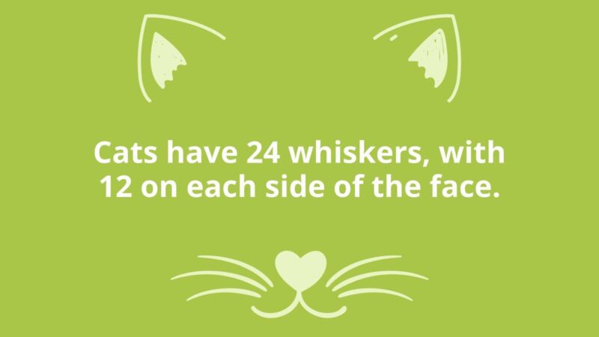
In addition to joke compilations, we have plenty of fun fact lists on our site with themes that will thrill your students. Plus they’re an educational way to teach your students new information during brain breaks. Get started with these fun feline facts to accompany the jokes above. Meow!

43. Practice another language
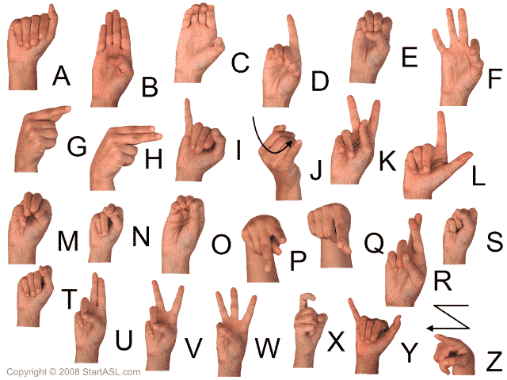
Source: startasl.com
Teach your kids the alphabet in sign language. Use brain breaks to practice by singing the ABCs while signing the letters. Then practice vocabulary words by spelling them out loud while signing the letters.

44. Find out how it’s made
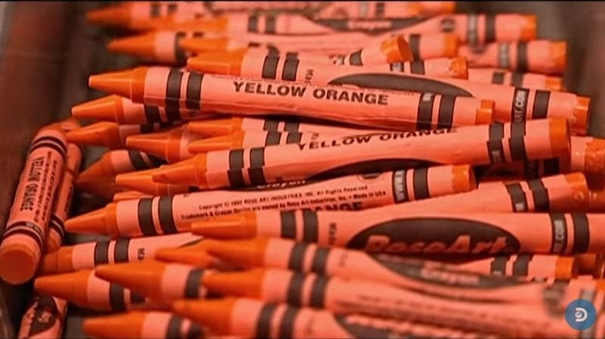
Remember that classic Sesame Street video about how crayons are made? We watched in awe as crayons rolled off the assembly line, wrapped in paper, and then slipped into those familiar cardboard boxes. Kids today are just as fascinated by how things are made! Here are our favorite videos about how things are made—from fireworks to LEGO.
ADVERTISING

45. Take a doodle break
According to researcher Mary Helen Immordino-Yang, downtime is essential for brain health. Kids need time for their growing brains to integrate and process the vast amount of information they receive each day. In other words, it is actually beneficial to give our kids time to allow their minds to wander. Try this: Set a timer for three to five minutes and let kids silently doodle with pencil and paper or a dry-erase board and marker while soft, calming music plays in the background.
Learn more: Sage Journals

46. Try a directed-drawing activity
Directed drawing activities walk your students through the process step-by-step so anyone can create their very own masterpiece. Teachers can lead the session by drawing on the whiteboard or chart paper while students follow along. Even better, there are plenty of videos on YouTube that lead the lesson, giving you a little break too. We have done the work and gathered some our favorite free directed-drawing activities for kids. Grab your favorite art supplies and get creative!

47. Gather your favorite GIFs
Make a slideshow of your favorite GIFs and have your kids act them out. Funny animals are a good place to start!
ADVERTISING

48. Find the object
Kids don’t even have to get out of their seats for this one, but they can! Have one student start by finding an object and saying, “I see something beginning with the letter [fill in the blank].” The first person to guess the item correctly gets to choose the next object. This can be a fun one to play on Zoom too! You can have kids add in additional clues to help.

49. Clap for a little call-and-response
Pep things up with a little call-and-response clapping. It’s simple to do and is often used in the classroom to get students’ attention. Simply clap out a pattern that your kids will repeat back to you. Switch out the pattern a few times until everyone is focused and engaged. Alternatively, try a vocal call-and-response. Sing out a few riffs and have kids echo the tune back to you.

50. Color yourself mellow
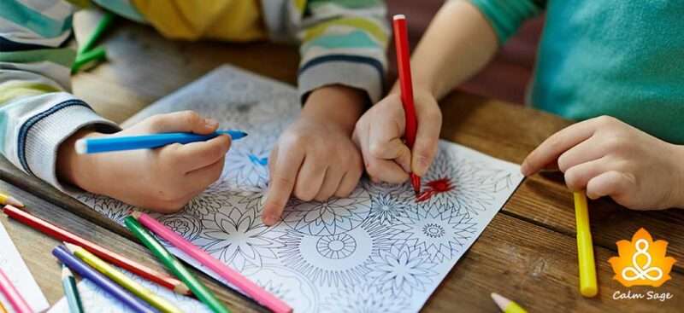
Even grown-ups have picked up on the coloring craze as an excellent way to calm down and zone out. Put on some nice mellow background music, set a timer, and pass out some of these free mandala coloring pages.

51. Try a brain-break spinner
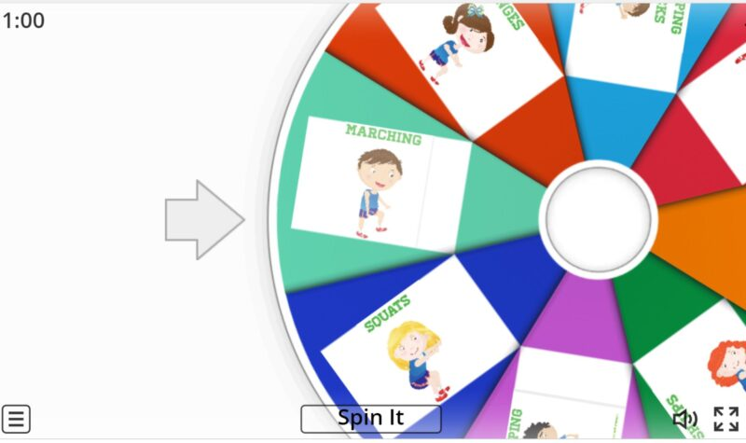
One way to make sure educational brain breaks are effective is to change up activities. Check out these online movement spinners for Wheel of Fortune–type games that help you add variety to brain breaks!

53. Would You Rather?
Students of all ages love participating in Would You Rather? videos, which can be found all over YouTube these days. Each video is approximately 8 minutes long, and students are given two scenarios where they choose which one they would rather participate in. Topics range from food items to activity choices to places to visit and more. As students choose the scenario, they move to either the right or left side of the room. Students then perform 30-second rounds of a specified exercise before repeating the process with another choice. Some of our favorite Would You Rather? channels include PE with Mr. G, Phonics Man, and Fix and Play. Students love when their teacher participates with them in the fun!
Learn more: PE With Mr. G

52. Write it out
Don’t underestimate the power of journaling or creative writing. Give your kids a 5- or 10-minute break to open up a page of their notebook and write about anything they’d like. They don’t have to share it with the class or do anything else with it; just use the quiet time to focus on something they love and want to write about.
ADVERTISING

