5 out-
This 5 out motion offense is an extremely simple offense to teach that could be used for a number of reasons.
- Primary offense. Throughout my varsity career, we utilized this offense with great success because it opened up the lanes for dribble penetration and cuts that allowed us to utilize our team's quickness. As a freshman in high school, I saw Cedar Rapids Prairie win the Iowa state championship using this as their primary offense.
- Easy To Teach - This offense could very easily be taught in one day!
- Delay offense. If you want to hold the ball until you get a lay up or the final shot to end the quarter, this offense is ideal for those situations.
- Foundation for any motion offense at any level. This offense can be used as a building block to teach your players basket cuts, back cuts, and how to react to dribble penetration.
- Great For Youth Teams - Great foundation as mentioned in #4 and you can teach more options as the team progresses.

Rules
- Rule 1 - Pass then basket cut. After the basket cut is made, fill the open spot along the baseline.  1 Cuts and fills the opposite baseline spot.  - Rule 2 - If the player in front of you cuts, replace him.  3 replaces 1.  5 replaces 3. |  | 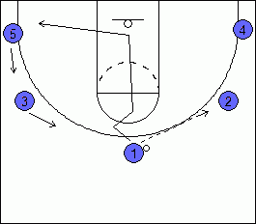
- Rule 3 - Cut Only When You Pass The Ball or when the player with the ball is looking at you.
- Rule 4 - The ball should only be dribbled to improve floor balance or beat the player.
- Rule 5 - Avoid passing to the corner very often & try to keep the ball above the free throw line extended.
Teaching Points To Better Execute The Offense:
These are some things that you will want to teach your players along the way. Be careful on teaching these points all at once. Otherwise, it can overwhelm them.
- All cuts are finished at the rim.
- Passer must watch the cutter all the way though. This helps with timing for the next player filling the vacant spot.
- When replacing the cutter, wait until the player with the ball is about done looking at the cutter. This will help with timing and setting up the defender for a back cut or straight cut.
- Back cut when the defender is near 3-point line. Some coaches like to say on the 3-point line, 1 step from the 3-point line, or 1 foot from the 3-point line. It's up to you to decide what works best for you.
- Always have the ball in triple threat and be ready to dribble penetrate. This offense can sometimes lull the defense to sleep which gives the ball handler opportunities to attack the basket.

Example of an Offensive Sequence
Remember, to execute this offense all you need to know are the 5 rules above. Those rules explain what to do in virtually every situtation. With that said, there are little teaching points that make this offense more effective. Below you'll find a sample sequence to help you see how everything fits together. As you go through the sequeunce, you'll notice that the 5 rules are always followed.
5 Out Set.  Very important to keep spacing for dribble penetration and cutters.  2 & 3 should be near the free throw line extended.  4 & 5 should be in the corners. |  | 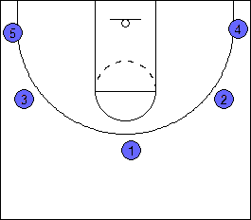

1 passes the ball to 2 on the wing.
After the pass, 1 basket cuts straight to the rim. Then, fills the spot in the opposite corner.
3 fills the spot on the top of the key.
5 fills the wing.

The defender guarding 3 pressures the pass and steps to the 3-point line.  3 back cuts. 2 looks to pass the ball if 3 is open.  3 fills the open spot along the baseline.  5 fills the top of the key.  1 fills the wing. |  | 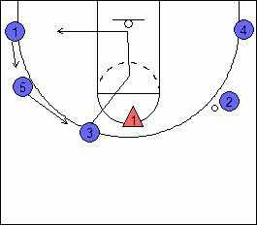

2 passes the ball to 5.  2 basket cuts and replaces open spot along baseline.  4 fills the spot. |  | 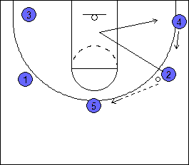

The pass is not open, so 4 back cuts. |  | 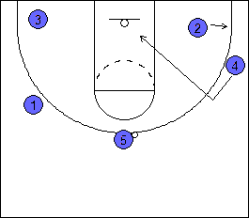

After 4 cleared the lane, 5 looks to the opposite wing at 1.  1 basket cuts  3 replaces. |  | 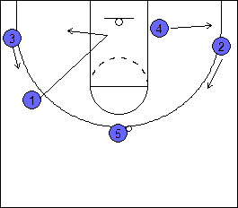

5 passes to 3.  5 basket cuts.  2 & 4 fill the open spots.  Remember, 2 & 4 should not replace as soon as 5 basket cuts. They want to pause until 5 has almost reached the basket to ensure proper timing. |  | 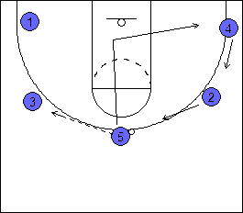

5 clears the lane.  3 dribble penetrates.  Penetration is cut off. 3 kicks it out to 1 in the corner. |  | 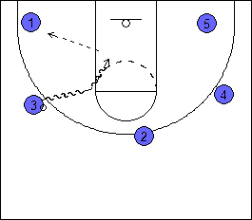

1 dribbles towards the wing to create floor balance.  As 1 dribbles to the wing, 2 back cuts.  1 passes to 2 for a lay up. |  | 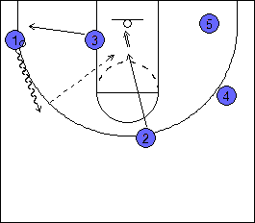

Other Situations:
Pass To Corner  Defender packs down near the lane in the corner to help on penetration and basket cuts.  If the player in the corner is a slasher or scorer, you can pass him the ball and allow him to shoot or attack. |  | 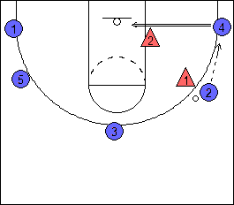

Prevent 5 second call  2 passes the ball to the corner to avoid the 5 second call and basket cuts. |  | 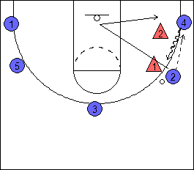

5 immediately dribbles to the wing and looks to the top of the key to start the offense again. |  | 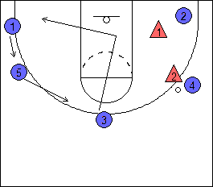

What To Do With A Good Post Player  If you have a good post player, you can give them permission to sit in the post for 2 seconds to try to get position.  1 passes to 2. 1 basket cuts.  1 cuts over to the post area to hold the position for 2 seconds.  3 hesitates to fill the spot until the post starts to clear. If 3 leaves too early, it can throw off the timing. |  | 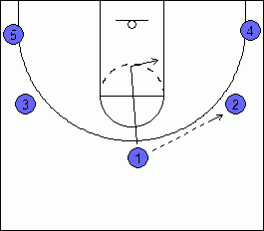

Two Low (best against man to man)
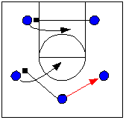 | The play starts when the point guard pass to either wing.  As soon as the pass is made, the point cuts to the opposite wing and sets a pick.  At the same time the low man on ball side also goes away from the ball to set a pick.  The two players receiving picks cut as shown.
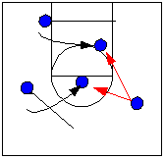 | The wing (with the ball) now has two options coming towards the ball. Time the play so the big man is the first visible. If he/she is not open, the wing player cutting to the free throw line area usually is for an easy shot.  OPTION: At this point, the low post cutting to the ball can elect to set a pick for the wing with the ball.
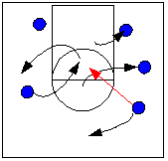 | If the first two cutters do not get a pass, the original point who went left to set a screen should seal his man, then cut down the middle. Sometimes, when the defense is scurrying after the first two cutters, there is literally no one in the key.  If no one is open, the players move as shown to the original start pattern. Remember, the play works either direction.

High Low (either man or zone)
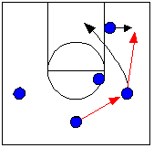 | The play starts when the point guard passes to either wing.  The high and low players must be on (or come to) ball side.  The wing may pass to either post, then cut to basket. This may be a give and go, or pick and roll with high post, too.  The low post may be open easier if he/she moves out corner.  Some defenses will try to prevent the pass to the post in the corner. This is a good thing! Fake a pass to your corner post, then let the corner post back door into scoring position.
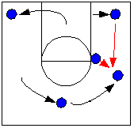 | The point guard replaces the cutting wing player. The weak side wing moves to point.  The post player receiving the pass may shoot, or pass to the cutter, but usually passes to the new wing on ball side.  The wing that cuts through the key goes to the far corner, then moves up to wing spot.
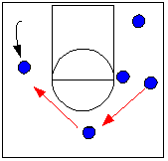 | The ball is quickly rotated over to the weak side wing. A mid-range jumper is usually available. If not, pass the ball to the new point guard and repeat the play.  IMPORTANT NOTE: This plays works best if your team has the patience to rotate the ball several times. It is tiring for the defense to follow back and forth. Eventually, someone will break down. Watch for an easy pass to the high post. Sometimes you will see the low post open up, too.

Four Out (best against zone)
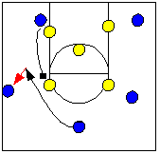 | This play works against a zone with either a two man or a three guard front. Seems most effective against a 3:2 zone.  Play starts when low post sets a high pick.  Point drives off pick and has three options: shoot, pick and roll with screener, or kick out to wing.
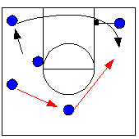 | If the point kicks out to wing, then he/she should continue to the corner, then go baseline to the other side of the court and use other post's pick along the way.  Meanwhile, the ball is rotated across to the weakside.
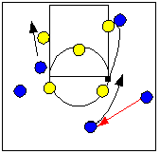 | The player that cut baseline may see a shot from wing. If not, pass to new point and wait for low post to set a high pick as before. Play is same, just mirror image.  This set gives one player four scoring options. If none work, another player is now in position to try the four options.

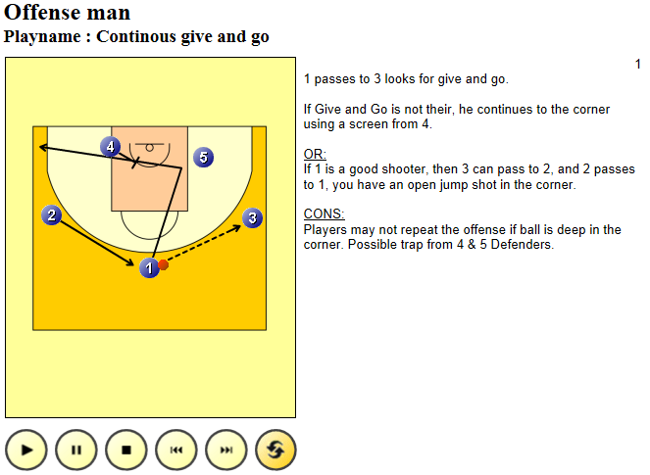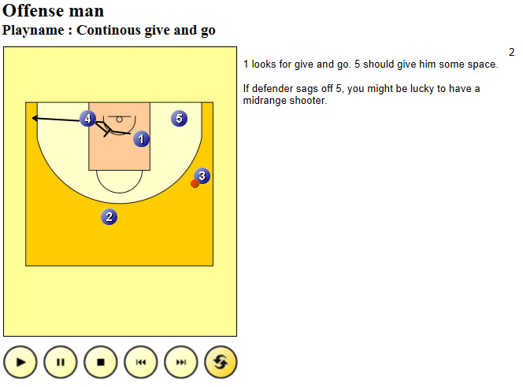
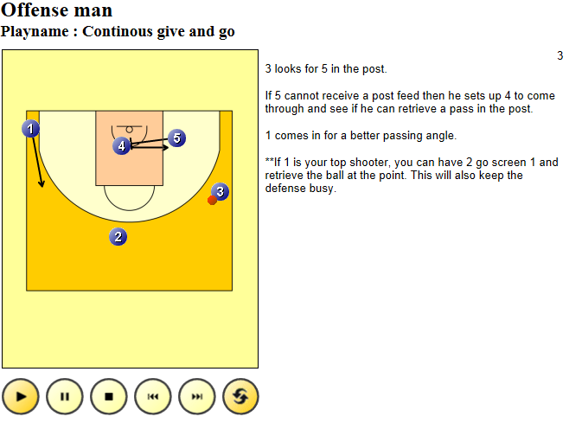
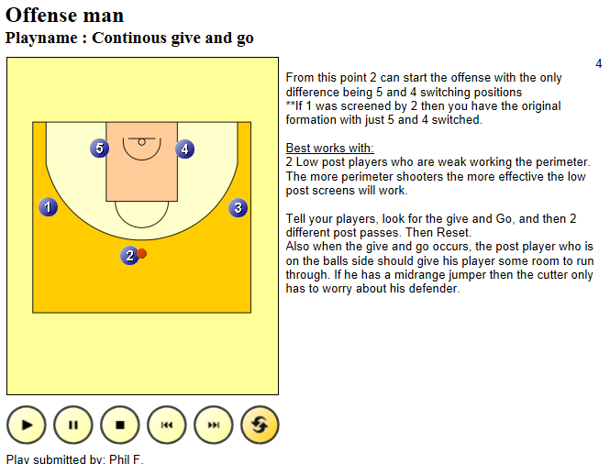

Basketball Offense - 1-4 High Stack Offense

The 1-4 offense tends to "flatten" the defense, and with the empty space under the basket, is ideal for back-cuts to the hoop, especially from the wing. In fact, when we are on defense and see this set, we expect underneath cuts. This offense also is effective against teams that over-play (deny) the pass to the wing (which makes them more vulnerable to the back-cut).
You can imagine some simple things, like O1 passing to a high post player, and then the wings O3 and O2 back-cutting to the hoop for the pass from the high post. Or the pass could go to a wing, and the near post screens away for the opposite post, who then cuts to the hoop for the pass from the wing. Several set plays are presented below.
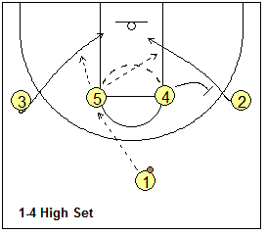

1-4 Stack, Post-Point Pick ‘n Roll, "41"
This play uses a simple high post screen for the point guard, and then the seal and roll by the screener (see Setting Screens). The same side wing (O2) slides deep into the corner to clear his/her defender out. This makes the wing O2 available for a "kick-out" pass to the corner for the outside shot (3-point shot).
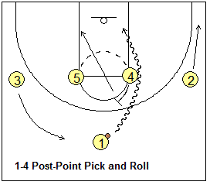

High-Post Pick-and-Roll, "45"
This is a simple high post pick and roll play where the pass goes to the player rolling off the screen. O1 is at the point, O2, O3,O4 and O5 stack across, at the free-throw line extended (diagram A). O1 calls the play and starts to dribble to the right to clear a passing lane. A jab step to the right or a pass fake to the right might work as well. Or O1 could pass to O2, and O2 to can make the pass inside. O4 sets a pick for O5 and seals the X5 defender (diagram B).
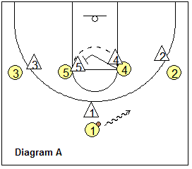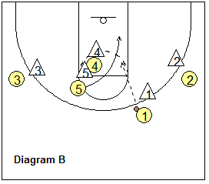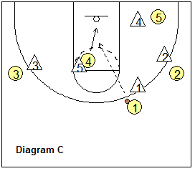
O5 cuts around the pick. O4's defender (X4) will probably switch and go with O5 on the cut. O5 takes the X4 defender with him to the baseline (out of the way and out of the paint). O4 now has inside position on the X5 defender and cuts to the hoop, for the lob pass from O1.

"Georgetown"
Run these plays off the 1-4 set. See the diagrams below. O2 and O3 cut low and cross to the opposite sides. O1 passes to either side (O2 in the diagram B), and the ball-side high post (O5) drops to the low post for the possible pass inside and post move. O2 could also shoot the 3-point shot.
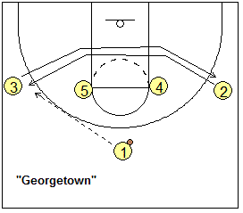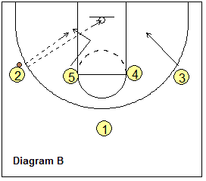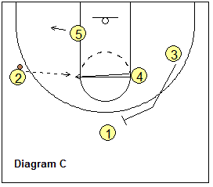
The opposite wing (O3) drops inside as a back-side rebounder. If O2 does not shoot or pass to the block, then O4 flashes to the ball-side high post, while O3 sprints up and back-screens for O1 (diagram C). O5 slides out to the short corner.
O1 cuts over O3's back-screen (diagram D) and could get the skip pass from O4 for the possble 3-point shot. O3 could also "slip", or seal and roll-off the screen, and cut up the lane for the pass from O4 (diagram E).
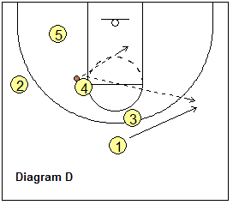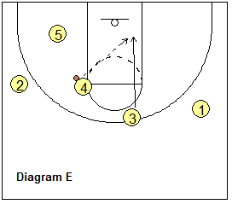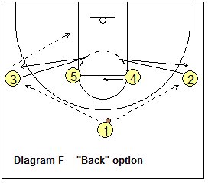
You can also run a "Back" option (diagram E) to keep the wing defenders "honest". O2 and O3 start their low cuts, but then suddenly cut back to their original spots, for a pass to either side. Then the rest of the play is run the same as above with the ball-side post dropping to the block, etc.

"Hoyas"
Again, start with the 1-4 set. See the diagrams below. O4 drops to the block and first back-screens for O2, and then for O3. O2 cuts low to the opposite corner, while O3 cuts low and crosses to the opposite wing for the pass from O1. Next (diagram B), O4 cuts up to the elbow and receives the pass from O3. O3 then slides up toward the top and O1 also moves laterally. Meanwhile, O5 drops inside and screens for O2, and O2 makes a "flex" cut over O5's screen into the paint, for the possible pass and shot. If O2 does not get the pass, O2 moves out to the corner, and O5 then cuts into the paint for the possible pass from O4 (diagram D).
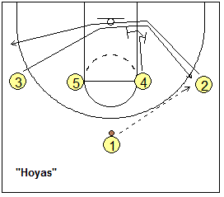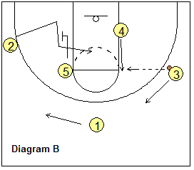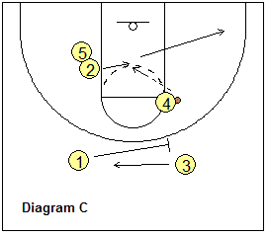
Notice that while the flex cut is being made, O1 back-screens for O3 (diagram C), and a pass from O4 to O3 for an outside shot is also an option (diagram D).
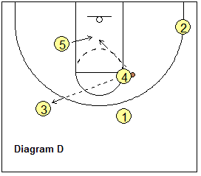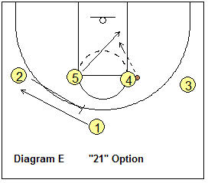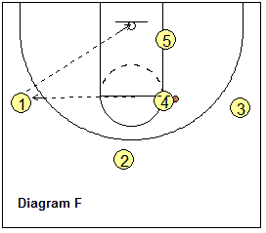

"Hoyas-21"
If you run "Hoyas" and find the flex-cut and the inside jammed with helpside defenders, run the "Hoyas-21" option instead (diagram E). The play is run the same as "Hoyas" with O2 and O3 crossing and the pass going to O4 at the high post. This time, instead of running a flex-cut into the helpside defense, O2 moves outside and back-screens for O1 (diagram E). O4 could pass to O1 for a 3-point shot (diagram F). Notice that we also have O5 cutting through the paint (diagram D) for a possible pass from O4 and the lay-up.

"4-Up"
Here's another play off the 1-4 set (diagram 4A). This play gives our athletic O4 a chance to play. O1 passes to O4 at the left elbow. O2 slides down to the corner and O5 pops out to the weak-side wing (for spacing). O1 cuts hard around O4 for a possible hand-off and dribble-drive (diagram 4B). O4 rolls to the hoop, like a pick and roll. O3 moves up top as our safety.
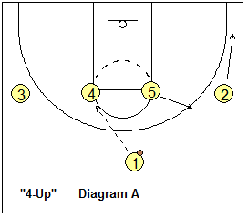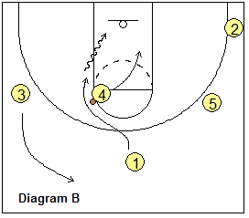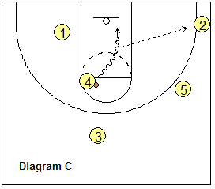
Often the defense will switch as O1 makes the cut around O4... O4 reads this and instead of making the hand-off, with a quick first step, dribble-drives around the defender for a lay-up (diagram 4C). Notice that we have O2 in the corner for a kick-out pass and 3-point shot.

10 Basketball Cuts Every Coach Must Know
January 31, 2013 by Coach Mac
Proper cutting movements are one of the most under-taught skills in our youth programs.
A lot of the time coaches don’t worry about teaching proper cutting to their players, they say it will ‘come naturally’ with time. Well I’m here to tell you it won’t. At least not proper cutting. Cutting that will get your players open when ever they wish during a game.
Players need to learn how to get open on their own. They’re not always going to be able to use a screen to get them open for a pass. Sometimes they’re going to have to do it in isolation. That’s what we as coaches need to teach them how to do.
Players like Reggie Miller and Ray Allen can score 30 points a game without taking a single dribble just because they’ve mastered the art of reading the defense and then using the appropriate cut to get them open for the pass.
In this article I’m going to describe and show you the 10 most common cuts in basketball.

1. Backdoor Cut
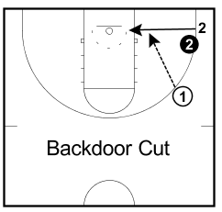The backdoor cut is used when the defender is over-playing in the passing lane denying the pass. Depending on your offence, this will leave a big hole to cut into between. If you are being denied the pass you will be able to backdoor cut.
The biggest problem with backdoor cuts is that it requires great passing skills by the person with the ball to result in an easy lay-up. This is why it is not a common pass in youth basketball. The lack of passing skills results in many turnovers.
For the backdoor cut to be most effective your players must set their defender up and have a quick change-of-direction and explode towards the basket.

2. V-Cut
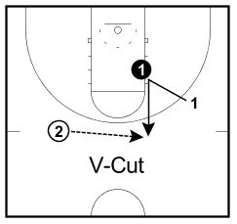V-cuts are the most common type of cut and are mostly
used when on the perimeter in isolation when you need to
get open for a pass.
V-cutting requires body-to-body contact by players. They are executed by walking the defender a couple of feet inside the 3-point line, planting your foot, and then exploding out to receive the ball.
It works because the defense’s reaction time won’t be quick enough to stop the player from receiving the pass.

3. L-Cut
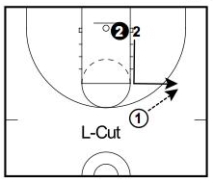L-cuts are a great way to get open on the perimeter when starting on the block.
This cut doesn’t require the offensive player to be quick, rather this cut will be most effective if good footwork is used and good use of the body.
Take the defender up to the elbow, get your top foot over theirs, give a small nudge to create space, and lead directly out to the wing while calling for the ball.

4. Curl Cut
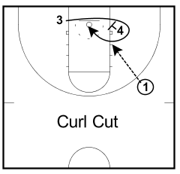The curl cut is executing a curl around a screen.
This cut relies on the offensive player reading his defender. If the defense follows around the screen, then a curl cut is the best option to receive an open lay-up. But if the defense cheats on the screen and goes over it, then the best cut would be the next one on the list, the flare cut.

5. Flare Cut
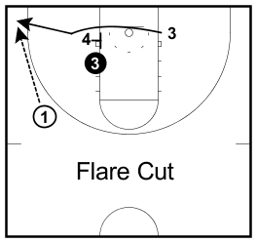The curl cut and flare cut go hand-in-hand.
When the defender cheats on a curl and tries to cut it off, players should flare out to the corner.

6. Deep Cut
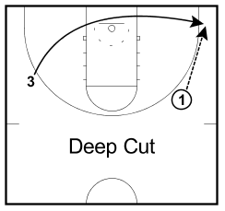
A deep cut involves the player on one side of the floor to cut baseline behind everyone and to the other side.
This cut is used a lot against zone defenses because often the defense doesn’t see the player cutting if they’re pre-occupied with the ball and other players.

7. UCLA Cut
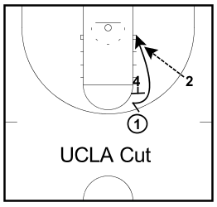The UCLA cut got its name because it was popularized by UCLA legendary coach John Wooden.
It involves a player at the top of the key making a pass to a perimeter player and then cutting directly to the block off a high post screen. If performed properly, this cut often leads to an open lay-up for the cutter.

8. Front Cut
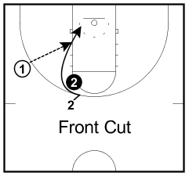
The front cut involves getting on the ball-side of your opponent.
Usually this is executed by performing a jab step or a small cut behind the defense to get them to move back. Once they do, you cut in front of them closest to the ball.

9. Shallow Cut
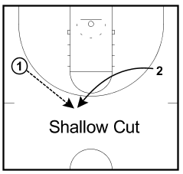A shallow cut is used when you’re exchanging positions with the person dribbling the ball. This means going underneath them and keeping your defender occupied while they fill the spot that you were in.

10. Flash Cut
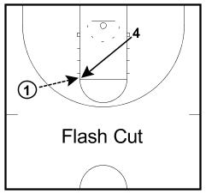A flash cut is a quick, explosive cut made by a post player to the high post.

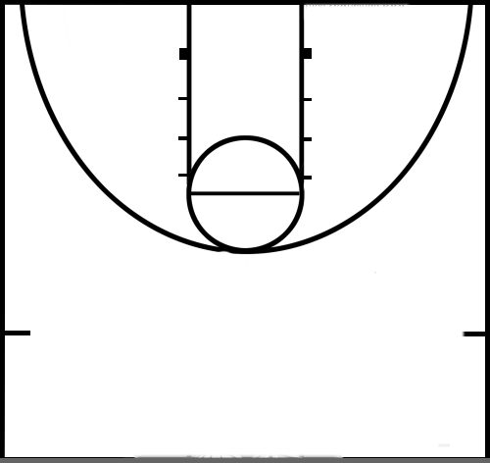
WINGS
5 cuts to hi post; 3 and 2 cut up to wings
3
2
4
1
Double stack to 4 out- call wings
5
1
4
2
5
3
4
3
4 rolls back to position; 3 replaces wing,1 replaces wing (reset)
2
1
5
1 passes to 5 then goes for a give and go; 2 replaces 1;4 screens for 3 who ball cuts looking for pass
3
4
1
2
5
4
1
2
5
3
5 passes to wing; 1 ball cuts, followed by a ball cut by 5- everyone moves one spot in direction of ball to replace
3
5
4
2
1
1 replaces opposite wing; 5 goes to hi post; 2 passes ball to top (reset)
How to Run the Give-and-go in Basketball
The give-and-go is one of the oldest and most fundamental plays in basketball. It’s easy to master and effective within any offensive set. Unfortunately, many coaches and players overlook the play’s ability to create an easy scoring opportunity.
The give-and-go is flexible enough that it can be run by any two players on the floor — one having the ball and the other receiving the initial pass. In general, the point guard initiates the give-and-go after bringing the ball upcourt. However, it can be run by a wing and a post player, or even two post players.
Pass & Cut
In the basic give-and-go, the ball-handler simply passes to a teammate and cuts to the basket. If the cutting man is able to free himself from the defender, he should receive a return pass as he’s cutting for an easy basket:
The pass can be a lob, bounce pass, or straight pass. However, it must lead the cutter on his path toward the basket.
The cutter should help the passer by raising his hand to signal that he’s open and ready for the pass.
In addition to its simplicity, the beauty of the give-and-go is the many options offensive players have when running it. How the cutter and passer react depends on the defensive players involved.
The Defender Goes for the Fake
When the defender moves with the initial pass or turns to watch it, the cutter should make a hard cut directly to the basket. Both offensive players should look for the reaction of the cutter’s defensive man to determine if a pass should be made. The cut must be quick enough so that the defensive player can’t recover.
The Defender Stays with the Passer
Hot Tip: Stay Involved
For the give-and-go to work, the remaining three offensive players must occupy their defensive players by decoying and creating space. If the other defensive players are occupied, they will be unable to help defensively to guard the cutter or passer.
When the defender stays home, the cutter should make a fake or V-cut, starting away from the basket and cutting sharply to the hole. Good cuts follow the slow-then-fast technique to get defensive players off-balance. Another move is to fake receiving a pass by raising your hands, which can cause the defensive player to overplay the passing lane.
Flexibility
The give-and-go’s strength is its flexibility within any offensive set. It can be the first pass in the half-court offense from the point guard to a wing player. It can also occur later in the possession following an entry pass to a post player. It’s ideal for aggressive defensive players who’re overplaying a passing lane or anxious to double-team an effective post or wing player. However, it also can be used against passive defenders who’re unprepared for a quick cut to the basket.
There are many underutilized give-and-go chances in basketball, such as:
Out of an in-bounds situation: The most dangerous player on the floor is usually the in-bounder. If the in-bound passer quickly cuts to the basket, he’ll often find an open passing lane.
On the fast break: The player receiving the pass usually draws all of the recovering defense’s attention on the fast break. A return pass is often the most efficient way to the get the ball down the floor quickly for an open shot.
Secondary break chances: Once the initial break has stalled, the defense is usually still recovering to account for every offensive player. This is a great time for the passer to cut to the hole for an easy basket.
Missed Opportunities
A cutting passer is one of the basic concepts in the motion offense, and a point guard often sprints to the basket after passing to a wing or post player. However, the cutter often fails to look for the pass, or the cut isn’t quick enough to create space. In the course of running an offense or set play, passers and cutters frequently forget to look at one of the simplest scoring chances: The pass back to the open cutter.
When the first cutter establishes himself as a threat, he’ll likely draw some defensive help, making it easier for other players to get open.
It’s easy for the cutter to forget to raise his hand to signal that he’s open, and the other three offensive players can sometimes forget to occupy their men. Also, the wing or post players often look for their own shot first and miss the cutting passer.
Remembering the give-and-go is easier said than done. Therefore, running a simple two-on-two drill in practice can remind players of its simplicity and turn that action into a second-nature habit.
Two-on-two Give-and-go Drill
Begin with a ball-handler at the top of the key and another offensive player to his right at the high wing. With a defensive player on each man, let the defender guarding the wing man play passively, allowing the initial pass. The cutter then runs a V-cut to the basket. If the defender overplays the passing lane, it allows the cutter a chance to fake the cut and pop out to the perimeter for an outside shot.
The wing player can either pass or penetrate to the basket if his man overplays the passing lane. The emphasis is on making the right choice, and two-man teams can keep score and play to 10.
Option Number One
The best way to make sure players don’t overlook the give-and-go opportunity is to always make it the primary option when beginning an offensive set. This is the basis of the “Triangle,” or “High-Post,” offense used so effectively in the National Basketball Association (NBA). When the passer always looks to cut and the receiver of the pass always checks the cutting action, opportunities are created and defenses must stay on their toes.

Read more at: http://basketball.isport.com/basketball-guides/how-to-run-the-give-and-go-in-basketball

